**Democracy Strengthening in Zambia (DSZ)**

**Quarterly Project Progress Update**

**Quarter 2: April – June 2021**

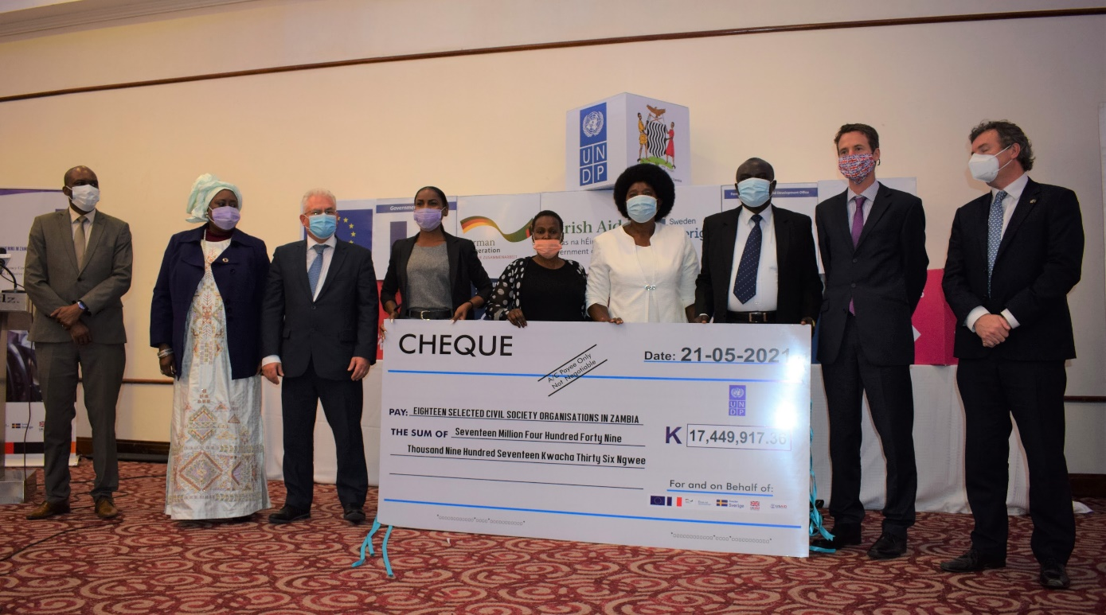

*with the financial support of the cooperating partners*



|  |
| --- |
| **Table of Contents** |

Project Cheat Sheet 3

Executive Summary & Context of the Action 4

Project Background 7

Snapshot of Actual Results achieved during the Quarter linked to the Results Framework 8

Project Progress Review for the Reporting Period 8

Result Area 1: Electoral Institutions and Processes Strengthened 8

Results Area 2: Programming for Peace 18

Project Management 22

Project Risks and Issues 26

Updated project risks and actions 26

Updated project issues and actions 27

Challenges and Lessons Learned 28

Conclusions and Way Forward 29

Financial Report 30

|  |
| --- |
| Project Cheat Sheet |

|  |  |  |
| --- | --- | --- |
| **Reporting Period** | April – June 2021 | |
| **Donors** | Multi-donor funding  (EU, Sweden, Irish, Germany, France, Ireland, USAID, UNDP & UK) | |
| **Country** | Zambia | |
| **Project Title** | Democracy Strengthening in Zambia (DSZ) | |
| **ATLAS Project ID** | 00124412 | |
| **ATLAS Output IDs** | 00119367: Electoral Institutions and Processes Strengthening  00119368: Programming for Peace  00119369: Technical Assistance and PM | |
| **Programmatic Contributions** | **7th National Development Plan (7NDP):** Pillar 5 – Creating a conducive governance environment for a diversified and inclusive economy -An Inclusive Democratic System of Governance  **United Nations Sustainable Partnership Framework – UNSDPF (2016–2021):** Pillar 3 – Governance and Participation, specifically:  Outcome 3.2: By 2021, all people in Zambia, including women, youth and marginalized, have equitable and effective participation in national and democratic processes.  **UNDP Strategic Plan – SP (2018–2021):**  Outcome 2: Accelerate Structural Transformations for Sustainable Development  Output 2.2.2: Constitution-making, electoral and parliamentary processes and institutions strengthened to promote inclusion, transparency, and accountability  **UNDP Country Programme Document – CPD (2016–2021):**  Outcome 2: Citizens expectations for voice, development, the rule of law and accountability are met by stronger systems of democratic governance. | |
| **Implementing Partner** | United Nations Development Programme (UNDP) | |
| **Project Start Date** | 1 January 2020 | |
| **Project End Date** | 31 December 2022 | |
| **Multiyear AWP Budget** | USD 12,159,352 | |
| **Total Donor Agreements Signed** | USD 10,224,132 | |
| **Total Funding Gap** | USD 1,267,663 | |
| **Revenue Received as of 30 June 2021** | EU | USD 1,286,166.00 |
| Germany | USD 576,315.56 |
| Ireland | USD 340,785.70 |
| France | USD 29,868.58 |
| UNDP | USD 400,000.00 |
| Sweden | USD 469,439.68 |
| USAID | USD 250,000.00 |
|  | FCDO | USD 691,341.78 |
| **Total Contributions Received** | USD 4,044,016.00 | |
| **UNDP Contact Person** | Roland Seri  Deputy Resident Representative,  UNDP Zamba  [roland.seri@undp.org](mailto:roland.seri@undp.org) | |

|  |
| --- |
| Executive Summary & Context of the Action |

1. The period under review marked significant milestones on the electoral calendar as several key activities took place ahead of this year’s elections. On 14 May 2021, Parliament was dissolved paving the way for the nomination of candidates (17 – 20 May) for the upcoming presidential, parliamentary, local government and council chairpersons’ elections. In total, 16 presidential candidates successfully filed their nominations. 12 May 2021 marked the beginning of the official campaign period with various political parties holding electioneering and mobilization events amidst the threat of the third wave of COVID-19. Unfortunately, the period was also marked by increased incidences of electoral violence in selected parts of the country leading to Electoral Commission of Zambia (ECZ) suspending campaigns for the governing party (the Patriotic Front - PF) and the leading opposition party (the United Party for National Development - UPND). At the project level, the reporting period also witnessed a heightened pace and increased volume of project activities, the majority of which were designed to support implementing partners in strengthening their role in the electoral process and their preparedness to deliver peaceful, transparent, and credible 2021 elections. The key activities conducted in the second quarter include:
2. **18 Civil Society Grants Award**. UNDP finalized the contract signing and award processes with the 18 civil society organizations (CSOs) that were selected to undertake voter education in the 10 provinces of Zambia. The 18 contracts are valued at USD 783, 386 (ZMW 17.4 Million) with 50% of this amount having already been processed for disbursement. The process of awarding the grants culminated in an official ceremony at Taj Pamodzi Hotel, Lusaka presided over by H.E Nick Whooley, British High Commissioner; Dr. Coumba Mar Cadio, UN Resident Coordinator; Mr. Yengwe Kakusa, Director of Governance, Ministry of Justice, and Mr. Kryticious Patrick Nshindano, Chief Electoral Officer, Electoral Commission of Zambia.
3. **Operationalization and Launch of the Early Warning Early Response System (EWERS**) against electoral violence. The Human Rights Commission of Zambia (HRC) with the financial and technical support of UNDP and partners operationalized and launched the EWERS for the prevention and de-escalation of the electoral violence. The system which was developed with the technical support of the European Union-UNDP Joint Taskforce on Electoral Assistance (UNDP-JTF) based in Brussels, has been customized to fit the Zambian context and will be run and operated by the HRC in collaboration with CSOs across the 10 provinces and 116 districts. The EWERS objective is to strengthen the existing conflict prevention and management systems in Zambia by providing the tools for data collection and analysis leading to informed and coordinated response.
4. **Operationalization of Mechanism to tackle Dis-information and Hate Speech (i-Verify Zambia Mechanism)**. UNDP completed the development and deployment to Panos Southern Africa Institute the IT solution (named iVerify Zambia) to tackle disinformation/misinformation and hate speech. The i-Verify Mechanism Zambia is a digital solution designed to counter disinformation, misinformation and hate speech before, during and after elections. The system was developed by UNDP working with the UNDP-JTF and is run by Panos Zambia and its partners, a network of journalists including MISA Zambia and Bloggers of Zambia, among other media stakeholders.
5. **Institutional Support to Electoral Dispute Resolution Mechanisms.** UNDP in collaboration with the Judiciary and ECZ held a colloquium on Electoral Justice and Preparations for the 2021 General Elections, for judges of the Constitutional Court, the High Courts, and the legal fraternity. The meeting which was held from 10th to 12th May 2021 brought together one hundred and twenty-five (125) participants, including sixty-four (64) judges from the two courts. The colloquium was held to share knowledge, experiences and identify best practices with jurists from other African countries who share similar history, legal frameworks and who have dealt with similar challenges in making decisions on election petitions.
6. **Zambia Police Electoral Security**. UNDP supported the Zambia Police Service (ZPS) in training 144 trainers of trainers in elections security training. The training is part of the ZPS’s efforts to adequately prepare for the policing of the 2021 General Elections. The training of trainers took place at Urban Hotel in Ndola. These trainers are expected to lead in the roll out of the electoral security training in the 10 provinces targeting about 20,000 police officers. By the close of the quarter, the ZPS had completed training for Northern and Muchinga Provinces targeting a total of 1176 officers. These are the officers who are earmarked for deployment on Election Day in the two provinces.
7. **United Nations Peacekeeping Operations Police Standing Capacity Technical Support**. Related to election security training above, UNDP solicited the support of the United Nations Peacekeeping Operations Police Standing Capacity (DPKO-PSC) to avail an expert to support election security especially the training of trainers and community policing specifically providing comparative experience sharing. The DPKO-PSC identified and deployed Lt. Colonel DeeDee Rodriguez to UNDP on detailed assignment between May and September 2021. Lt. Rodriquez is currently in the country and is working with the ZPS in the areas of electoral security, community policing and media.
8. **Training of CSOs in Grants Management**. UNDP built capacity of fifty-six (56) CSO personnel to safeguard and enhance management of grants to the 18 CSOs. The CSOs were trained at a two-day workshop held at Taj Pamodzi Hotel in Lusaka. The objective of training was to clarify their roles and responsibilities with regards to the grant award. The training covered various aspects of the grant management including Financial Reporting and Management, Operational Risk Management; Media Management; Role of CSOs in Elections; Communication and Visibility, and Monitoring and Evaluation. The training was attended by heads of the CSOs, finance officers and program officers (3 per organization).
9. **Campaign Venue Management System (CVMS) Political Parties Dialogue**. UNDP working with the partners (Democracy Works, ZPS and Zambia Centre for Interparty Dialogue - ZCID) convened a one-day workshop to bring together political parties to discuss their role as agents of conflict mitigation and discuss the proposed architecture of the CVMS being led by ZPS, with ZCID’s support. The workshop which was held under theme ‘The role of political parties as agents of political and electoral conflict mitigation’ was designed to foster knowledge and understanding across political parties on their role as agents of political electoral conflict management and how they can harness technological systems such as the CVMS to increase transparency and accountability in mitigating conflict over campaign venues. The workshop validated the proposed concept of the CVMS and reached consensus on the implementation strategy of the CVMS ahead of the 2021 general elections and beyond.
10. **Resources Mobilisation**. In April 2021, UNDP received funds from the new partner to the DSZ funding basket, the United Kingdom’s Foreign and Commonwealth Development Office (FCDO) with their full funding commitment of GBP 500,000 (USD 691,341.78). This brought the total funding contributions received by the project towards the funding basket to USD 4, 044,016. It should be noted that USD 2,017,593.72 were retained from the 2020 budget. With the receipt of funds from UNDP and FCDO, only USD 2,908,934.50 has been available for implementation of activities in 2021 so far.
11. **Budget and Expenditure.** As of 30 June 2021, the project’s expenditure stood at USD 2,473,412.55 (inclusive of advances and legal commitments) which is 30% of the 2021 budget of USD 8,329,867.57 which was proposed to the Steering Committee of 2 February 2021 and was still under revision by reporting time. This expenditure represents of 20% of the project’s overall Multi-Year Budget of USD 12,159,352.

|  |
| --- |
| Project Background |

1. The DSZ project is predicated on the recommendations of the Needs Assessment Mission (NAM) conducted by the Electoral Assistance Division (EAD) of the United Nations in 2018 and is aligned and supportive of Zambia’s *Sustainable Development Partnership Framework*, *UNDP Strategic Plan* and *Country Programme and the 7th National Development Plan 2017-2021 (7NDP)*. The project contributes to Pillar 5 of the 7NDP to “*promote transparency, accountability, citizen participation as well as strengthen governance institutions*”[1].
2. DSZ uses a two-pronged approach of 1) *Strengthening Electoral Institutions and Processes* and 2) *Programming for Peace*. The project aims at strengthening the institutional capacity of key electoral stakeholders to ensure procedural certainty and strengthening the legitimacy of the electoral process based on the Electoral Cycle Approach (ECA). The DSZ further seeks to strengthen conflict prevention and mitigation mechanisms to support the peaceful conduct of elections through an institutionalized Early Warning and Response System (EWS) at the national, provincial, and local levels. The EWS comprises data gathering, incident reporting and monitoring, training and documentation and targeted interventions by both state and non-state actors
3. The DSZ’s expected outcomes and activities resulted from detailed consultations between Zambian electoral stakeholders, on the one hand, and UNDP and the project donors, on the other hand. The Zambian electoral stakeholders include: the ECZ, the National Assembly, the ZPS, the Judiciary, political parties, media, and civil society including community and faith-based organizations.
4. The DSZ results areas of *Electoral Institutions and Processes Strengthened,* and *Programming for Peace* are interlinked with following six (6) key results:
5. *Inclusive and participatory decision-making.*
6. *Strengthened responsive and accountable institutions.*
7. *Transparent institutions with improved access to information.*
8. *Improved technical and organizational capacities of national electoral stakeholders.*
9. *Credible and legitimate institutions work with integrity, and*
10. *Enhanced conflict prevention and mitigation mechanisms.*

# Snapshot of Actual Results achieved during the Quarter linked to the Results Framework

|  |
| --- |
| Project Progress Review for the Reporting Period |

1. In this section of the report, a detailed description of all the activities undertaken by the project in the second quarter of 2021 is provided. The sections outline the various activities undertaken by UNDP and the various government and civil society partners with the financial and technical support of the DSZ Project. The activities are presented and described in order of the of the six (6) result areas of the project as they appear in the workplan.

## Result Area 1: Electoral Institutions and Processes Strengthened

### 1. Decision-making is more inclusive and participatory, and discrimination is reduced

1. UNDP finalized the report and strategy document outlining implementation strategies aimed at fostering the participation of Women and Youth in elections. The *Strategies and Outreach Activities to Increase Women and Youth Participation in Elections* report is the outcome of the broad-based consultation of stakeholders led by a project consultant, Dr. Nalukui Milapo. The development of the strategies and activities contained in this report involved gathering of evidence on women and youth participation in elections using a multi-pronged approach involving both primary and secondary data. In-depth interviews were conducted with female (8) and youth (6), potential and aspiring candidates for the 2021 election, serving women (3) and young politicians (4) in different organs of the parties represented in parliament. Also consulted were various state and non-state actors that including the ECZ, ZPS, HRC, Women Parliamentary Caucus, Zambia National Women’s Lobby (ZNWL), Women for Change, and political parties such as PF and UPND, among others. The report was finalized following a validation workshop held at Sarovar Hotel on 20 May which was attended by 14 stakeholder organizations’ representatives, five of whom were male and nine were female. The final document was provided to CSO grant recipients to build in the strategies in their voter and civic education outreach activities particularly the importance of inclusion of women and youth in the electoral process as candidates and voters.
2. Further, UNDP signed Low Valued Grants contracts with 18 CSOs to implement targeted activities aimed at increasing electoral participation of women, youth, people in lawful custody (PLC) and people with disabilities (PWD). All the signed grants amount to USD 783, 386 (K17.4 Million). Among the 18 grant recipients are 3 renowned women’s interest organizations namely ZNWL, Young Women Christian Association and Young Women in Action. The list also includes youth-focused organizations such as Anti Voter Apathy Project (AVAP) and Operation Young Vote (OYV). These organizations have gained significant experiences from successive general elections which will enrich the project’s quest to enhance voter participation among women, youth, people with disabilities and people in lawful custody. The 18 organizations are spread across the 10 provinces and measures have been taken to ensure that there is no duplication within each geographic area.

1. Furthermore, UNDP contracted a third-party firm to develop and produce voter education messages on women and youth inclusion and participation in the electoral process on behalf of ECZ. By the end of the reporting period, the messages which are in form of posters, docu-dramas, radio, and TV spots were undergoing review and validation in readiness for placement and broadcasting. The details on the contents are discussed further under Results Area 4.

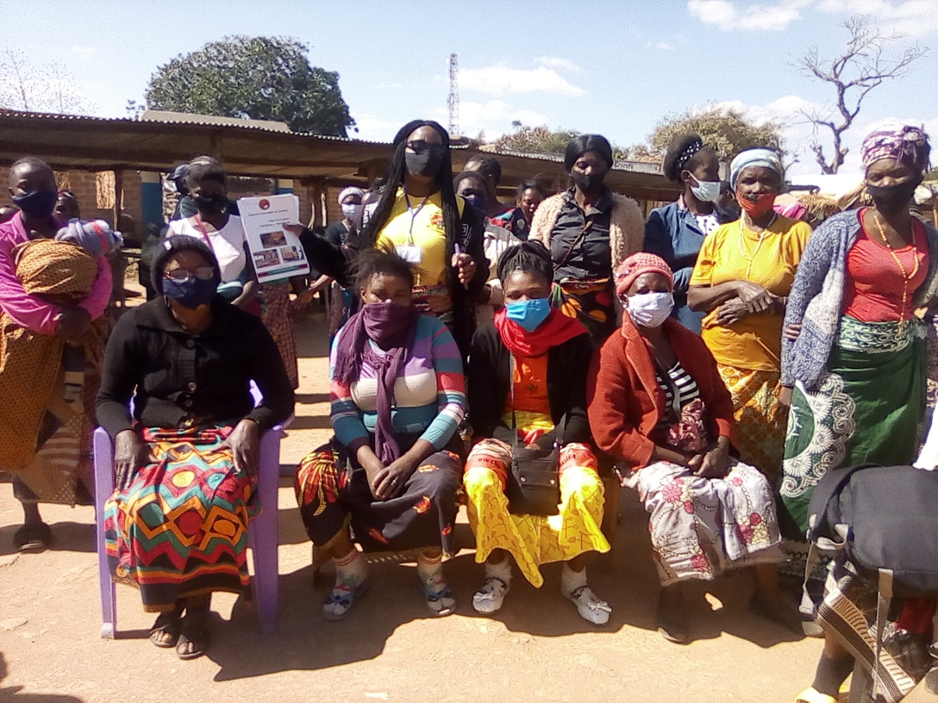

Picture 1: A Civic and Voter Education Facilitator (standing in the back row holding publication) from AVAP pose for a group photo at Pemba Market at the end of voter education session.

1. In the area of outreach activities to increase women and youth participation, the project was able to reach out to several communities around the country. This was largely achieved through the CSOs grantees. In the period under review, various outreach activities were conducted by the CSOs targeting sixty-six (66) districts across the country. As at the end of the second quarter the CSOs collectively mobilized and trained 1262 voter education facilitators who were deployed in various communities at ward and constituency level across the country to undertake voter education in hard-to-reach areas. The training and deployment of these foot soldiers is ongoing. For example, AVAP trained 26 voter education facilitators and provided them with handheld megaphones and bicycles to conduct door to door voter education in communities in Katete, Choma and Chilubi districts. Edutainment Health Foundation, CSO working in central province trained and deployed 102 voter education facilitators to various wards of its 12 districts.
2. The CSO grantees were also able to procure airtime in local community radio stations and organize ninety-five (95) radio-based voter education programs. According to ZICTA (2018)[2] forty percent (40%) of households in Zambia have access to a radio making it an important source of news, education, and information for the 7 million voters especially in rural areas. The live programmes featured local community leaders discussing various aspects of the 2021 elections. For instance, Caritas Mansa paid for and held six (6) hour long discussions and phone-in radio programmes that were designed to raise citizens awareness of the electoral process and encourage participation of women and youth. MISA Zambia also provided capacity building training to 10 community radio stations in electoral radio Programme design. Twenty (20) radio producers from these radio stations were trained. These radio stations will then produce a series of 20 radio programmes on various aspect of the voting process to educate and inform the targeted communities.
3. Given the many COVID-19 restrictions imposed on face-to-face community mobilization activities, some CSOs took advantage of the social media platforms to undertake voter education and electoral awareness activities. There were four (4) major social media engagements that were held by SACCORD using social media influencers[3] (Mwiza Zulu, WeziheartSound, Sister D, Cosmas Ngandwe) that had a reported at the close of the reporting period a combined social media reach of 37, 928 people.
4. During the same period, a national consultant, Mr. Mike Chivumo who was engaged to review existing procedures, strategies, publications targeting PWDs for meaningful participation in elections presented his final report to UNDP. The report presents a situational analysis of the PWDs as regards participation in the electoral process and identifies key strategies to enhance their participation in this year’s elections and beyond. The report is the culmination of a desk review and key informants’ interviews with key informants drawn from organizations working with PWDs and electoral stakeholders. The recommendations of the report have been incorporated in the programming with the CSO grants and is currently informing the current and future engagement with PWD in the electoral process.

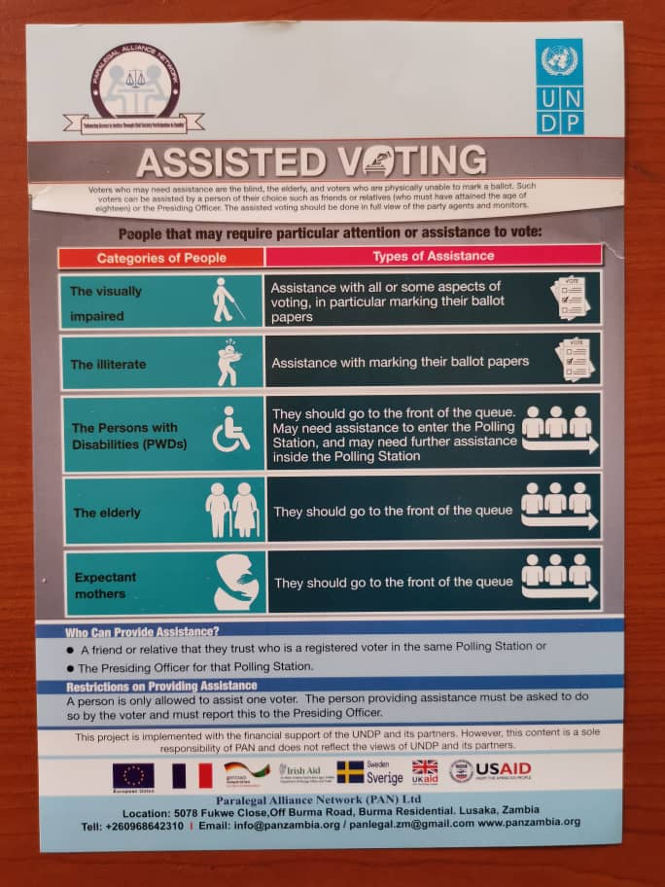

Picture 2: A flyers produced by one of the CSO grantees - Paralegal Alliance Network - on ‘Assisted Voting’ targeting People with Disabilities.

1. In its effort to increase participation of the PWDs in the electoral process specifically the upcoming 2021 elections, UNDP supported the development of posters, radio and TV messages and docu-drama targeting PWDs. These information products were done in English and translated into seven (7) local languages to extend their reach. They were produced through the third-party media contract more fully described in Result Area 4. Further activities to enhance the participation of PWDs in the electoral process were conducted by CSO grantees. One of the CSO targeting PWDs in civic and voter education was the Paralegal Alliance Network (PAN) which trained 44 voter education facilitators who will focus on mainstreaming disability issues in the target communities. PAN has also produced voter education manuals for PWDs and posters with targeted messages on disability and the electoral process. In total, over 200 posters and 15,000 flyers with messages such as “*We support the vote of people with disability!*”, “*Assisted voting*” etc.
2. In this period the project’s technical and logistical support enabled the legislative drafting and legislation efforts to formalize the constitutional court judgement for the PLC’s right to vote. The legislation was passed by Parliament in May. By the end of the reporting period, the bill awaited the President’s assent. To advance the realization of voting rights of PLCs, the project awarded two grants to prison focused CSOs, namely, Prison Care and Counselling Association (PRISCCA) and Prisoners’ Future Foundation (PFF) to undertake voter education activities in all the correctional facilities in the country. The two grants have a total value of USD 79, 671(ZMW1.8 Million). To ensure full coverage of all correctional facilities and avoid duplication, each organization was allocated 5 provinces to undertake voter education in correctional facilities. PRISCCA is covering Lusaka, North-Western, Luapula, Northern and Southern provinces, while PFF is covering Central, Copperbelt Eastern, Muchinga and Western provinces. With the financial and technical support of the project, the two CSOs are leading outreach activities to increase participation of PLCs in this year’s elections.

Picture 3: Dr Godfrey Malebeka, the Executive Director of PRISCCA poses with a dummy cheque indicating the grant amount received from the DSZ Project

1. Thus far, the two CSOs were able to conduct voter education and electoral process awareness activities in 39 centres. Working with the Correctional Services authorities, PRISCCA established 13 inmates’ Voter Education Committees and trained 130 inmates as voter educations facilitators. These voter education facilitators are responsible for organizing and delivering voter education and electoral process awareness among fellow inmates. By the end of the reporting period, over 7,000 inmates had been mobilized and provided with voter education using this approach. On the other hand, PFF’s recruited and trained 26 interns to conduct voter education in correctional facilities under their catchment area (Northern part of Zambia). Thus far 1,952 inmates received voter education messages and electoral process information, education, and communication materials. Therefore, by the end of the reporting period over 50% of the eligible PLC voters were reached with various voter education and electoral process information.

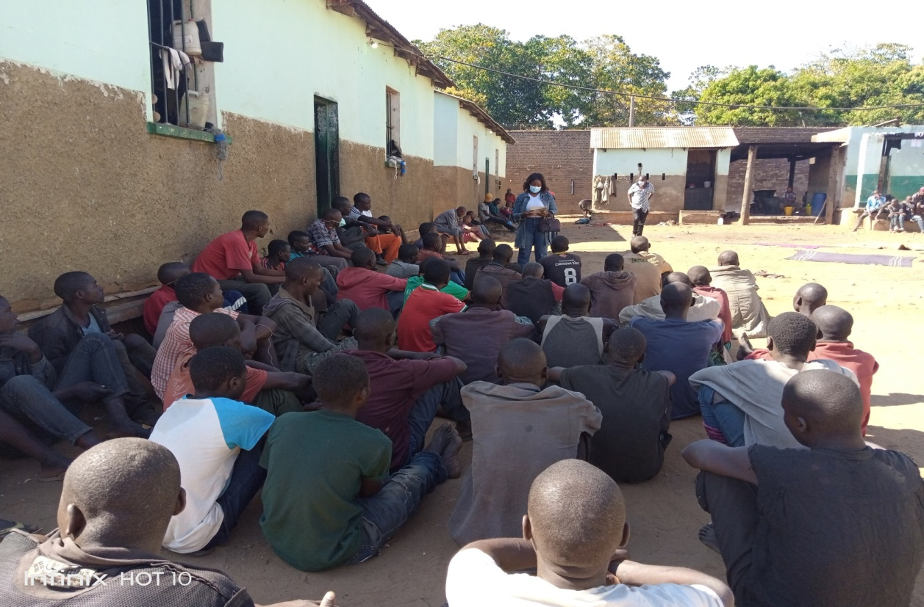

Picture 4: Inmates attending voter information and education sessions organised by Prisoners Future Foundation at Katete Correctional Facility

1. UNDP made strides in its effort to support the operationalization of the Domestic Election Monitoring and Observation Group (DEMOG) Charter for local CSOs. The local and international consultants hired by UNDP to support the review and operationalization of Domestic Election Monitoring and Observation Charter concluded their work and produced the final strategy document. Based on the recommendations by the consultants, UNDP is using lessons from the 2016 elections to support local CSOs involved and accredited in observing the elections and to build their capacities through the Christian Churches Monitoring Group (CCMG). An important element of this support is to help improve their strategic planning capacities well in advance of the deployment of observers for the 2021 elections. To achieve this, a consultancy was commissioned to review the current practices by CCMG and seek ways to improve existing capacities by strengthening the coordination mechanism of observation of elections by domestic CSOs.
2. The work of the two consultants (Mr. Taona Mwanyisa and Dr. Lee Habasonda) culminated in the production of a strategic document for an improved framework for accreditation, sustainability, and operations of domestic election observers. This document is intended to give life to the DEMOG Charter which was developed and validated by several CSOs involved in election observation and monitoring. The document establishes an accountability mechanism for CSOs participating in election observation. The strategy was validated by CSOs at a workshop held on 16 May at Sarovar Hotel. The workshop was attended by 24 representatives (6 females, 18 male) of stakeholder organizations. The next step is for the project to finance the implementation of the strategy ahead of the August 12 elections. By the end of the reporting period, the DSZ project had advertised for the recruitment of a DEMOG coordinator.

### 3. Institutions are more transparent and provide access to information

1. In line with the DSZ overall objective of achieving electoral justice and peace, and the specific objective of strengthening the Judiciary’s Electoral Dispute Resolution (EDR) processes, UNDP in collaboration with the Judiciary organized a two-day colloquium on electoral dispute resolution from 10 to 12 May 2021 at the Taj Pamodzi Hotel in Lusaka. The colloquium was aimed at draw lessons from regional experiences in electoral dispute resolution. The colloquium drew the participation of sixty-four judges, sixteen local, regional, and international resource persons, the Law Association of Zambia, and administration staff of the Judiciary. In total, one hundred and twenty-five (125) participants attended the colloquium. The list of facilitators included three facilitators from Zimbabwe, Kenya, and an international jurist. These facilitators led in sharing experiences and best practice on EDR via South-South cooperation.

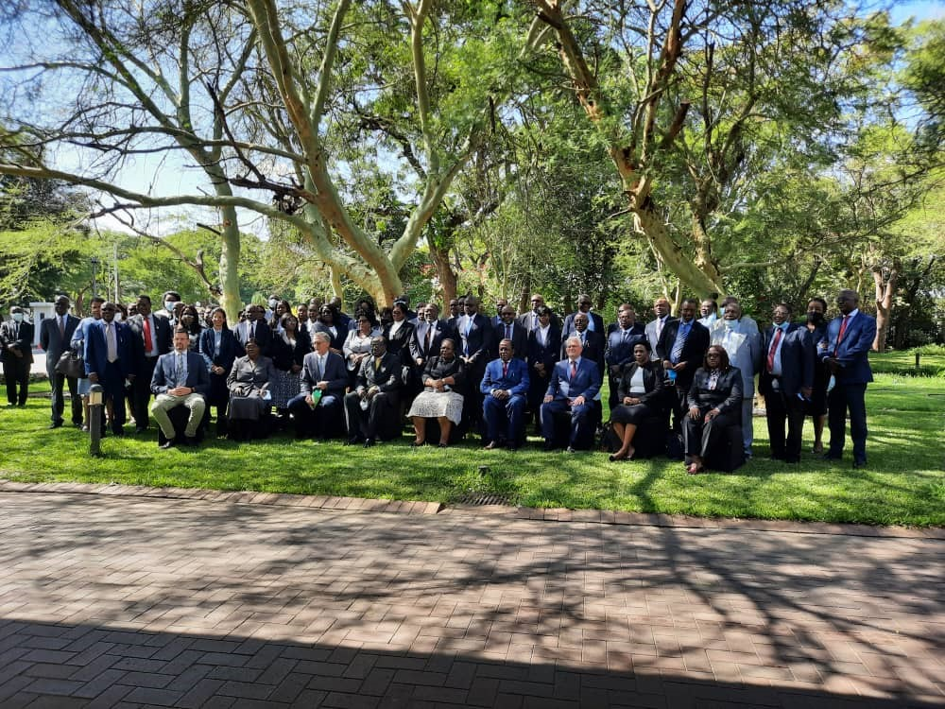

1. A legal consultant, Mr. Thomas Maosa was also engaged to support the Judiciary assess EDR-related training needs and gaps. By the end of the reporting period, the consultant had submitted a training plan for judiciary staff which is expected to be implemented by end of July 2021.

### 4. Technical and organizational capacities of national electoral stakeholders strengthened

### 

1. On 17 May 2021, UNDP organized a stakeholders’ workshop at Sarovar Hotel, Lusaka to validate the draft report on disinformation and fake news especially in relation to the 2021 elections and beyond. The workshop also had a secondary objective to discuss the key findings and recommendations and kick-start the next practical steps and remedial actions for countering and dealing with the phenomena. The meeting was attended by 19 representatives (9 females and 10 males) of stakeholder institutions adopted the report and the proposed the architecture for the implementation of counter measures. The adopted architecture will see Panos being the lead agency and coordinating the other stakeholders involved in the implementation mechanisms.
2. As the outcome of this validation process and agreement on the implementation architecture, Panos signed a letter of agreement (LoA) with the UNDP to become the leading implementing partner of the mechanism to identify and counter disinformation, misinformation and hate speech.

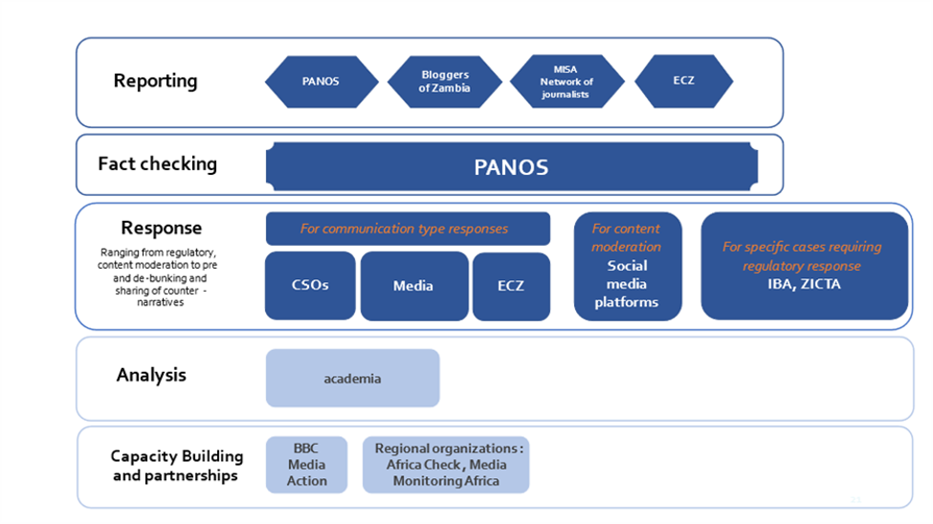

Figure 1: A conceptualisation of the implementation arrangements and roles and responsibilities of stakeholders involved in i-Verify Zambia Mechanism

1. To this end, PANOS in collaboration with Bloggers of Zambia, MISA, ECZ, BBC Media Action and many others operationalized the system now customized and named ‘i-Verify Zambia’. The i-Verify Zambia is a web-based platform (<https://iverify.org.zm/>) and mechanism for the identification and mitigation of disinformation, misinformation (fake news) and hate speech. This remarkable platform is expected to contribute to inclusive, peaceful, and credible elections for the August polls. The iVerify Zambia system is not only designed to add value during the electoral cycle but also beyond, serving its purpose in the long-term by contributing to information integrity across all fields of governance.
2. The i-Verify Zambia Platform is the result of broad-based consultations and extensive analysis and complements and strengthens the existing efforts for identification and mitigation of threats to information integrity in Zambia by providing the tools for data collection and analysis leading to informed and coordinated responses. The i-Verify Zambia Initiative aims at (1) strengthening national capacity to identify and document cases of disinformation, misinformation and hate speech; (2) analyzing and fact-checking the information at local level; and (3) activating remedial response through counter-messaging or regulatory decisions. The official launch of the i-Verify Zambia is scheduled for July 2021.
3. During the period under review, UNDP finalized the procurement and signing of contract with a Third-Party Media company to support the ECZ in developing an electronic media-based campaign ahead of the 2021 elections. The company, Blackdot is developing electronic and paper-based voter education media content for and on behalf the ECZ. The media content being developed under the broad theme dubbed ‘Make Your Vote Count’ Campaign communicates to the Zambian voter that s/he has, in the upcoming election an opportunity to make a decision that affects their future, that of their family and of the country. The campaign calls on all Zambians to turn up and vote in the 12th August 2021 general elections and make their vote count. The campaign also calls for Zambians of all persuasions to respect each other’s political choices, be tolerant and peaceful in the run up and aftermath of the elections.
4. Blackdot has also developed the media placement plan, which will be implemented by ECZ in collaboration with UNDP. Thus far, Blackdot has completed and submitted to UNDP and ECZ for review and approval the following items:

|  |  |  |  |
| --- | --- | --- | --- |
|  | Item Description | No. | Comment |
| 1. | Posters | 40 | 5 Produced in English and translated in 7 vernaculars (Bemba, Lozi, Luvale, Lunda, Tonga, Nyanja, and Kaonde) |
| 2. | Radio Spots | 40 | 5 Produced in English and translated in 7 vernaculars |
| 3. | TV Spots | 40 | 5 Produced in English and translated in 7 vernaculars |
| 4. | TV Docudrama | 32 | 4 Produced in English and translated in 7 vernaculars |
|  |  |  |  |

### 5. Credible and legitimate institutions work with integrity

1. Two consultants (Dr. Lee Habasonda and Mr. Taona Mwanyisa) working on legal and regulatory assessment, consolidation and analysis of observer recommendations submitted their final report following the validation workshop held on 20 May at Sarovar Hotel in Lusaka which was attended by 24 stakeholders’ representatives (6 female, 18 male). The consultancy was commissioned to review the current legal framework of elections and to ascertain the extent to which the framework is consistent with good electoral practices and international standards as encapsulated in the key legal instruments (both international and regional) that Zambia is a signatory to, including recommendations of past election observer missions.
2. The assignment identified gaps in the current legal framework for elections in the country and recommended ways to fill such gaps. The final report acknowledges that while election observer recommendations are non-binding or may not be feasible to implement at a given time, it was important to assess which election observer recommendations are relevant to the context of the country and may be incorporated in the current legal framework. This report aims to assist consideration of the recommendations by the authorities and organizations, such as the Parliament of Zambia, the ECZ, the ZPS, political parties, CSOs, and the media.

## Results Area 2: Programming for Peace

### 6. Conflict mitigation mechanisms to support the peaceful conduct of elections are enhanced

1. UNDP solicited the support of the UN Police to avail an expert to support the DSZ and ZPS in election security matters especially the training of trainers. The DPKO-PSC identified Lt. Colonel DeeDee Rodriguez and deployed her to Zambia to join DSZ team on detailed assignment between May and September 2021. She has since arrived in Lusaka and commenced work to support the ZPS.
2. Further, UNDP in its effort to support the ZPS’ capacity to effectively police elections, financed the printing of various types of teaching aids and reference materials to assist in the delivery of the electoral security and human rights training. The breakdown of the various types of teaching aids and reference materials is provided below:

|  |  |  |
| --- | --- | --- |
|  | Type of teaching aid/reference material | Quantity Printed |
| 1. | Handbook on Policing Elections in Zambia | 3, 600 |
| 2, | Pocket Book on Policing Elections in Zambia | 20, 700 |
| 3. | Training Manual on Policing Elections in Zambia | 300 |

1. UNDP also supported the training of 144 trainer of trainers’ electoral security and human rights for the ZPS. The training was held at the Urban Hotel in Ndola. The trainers were trained in two groups of 72 each during the period 6 to 14 May 2021. The meeting was officially opened by the Inspector General of Police, Mr. Kakoma Kanganja, with the Head of Governance and Gender, Mr. Gregory Saili representing UNDP.

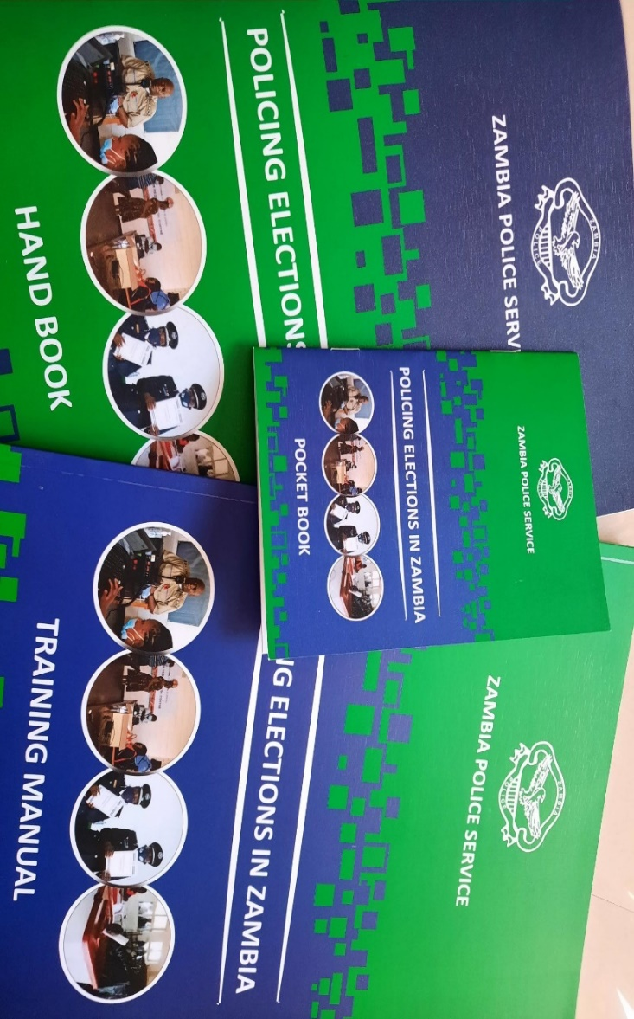

Picture 5: Electoral security materials printed with the support of DSZ Project

1. In June, the ZPS with the financial and logistical support of UNDP began rolling out electoral security training to the provinces beginning with Muchinga and Northern provinces. The trainings in the two provinces were conducted by trainers from the police service headquarters, provincial headquarters, and districts. They were among those who were previously trained in Ndola. The trainings were held in each of the districts in the two provinces and a total of 904 (403 Northern and 501 Muchinga) police officers attended the training. The training for the remaining 8 provinces is scheduled for July 2021.
2. During the period under review, the project provided technical and financial support to a joint training held from 9 to 16 June 2021, between the police and media in which 23 master trainers were trained in preparation for the rolling out of training country wide. The intervention was aimed at strengthening collaboration and raising awareness between the ZPS and the media as they prepare for the 2021 general elections.
3. In the quest to strengthen stakeholder consensus on campaign venue management, UNDP convened a one-day workshop to bring together political parties to discuss their role as agents of conflict mitigation and to further discuss the concept of the CVMS under the leadership of the ZPS during the 2021 elections and beyond. The consultative meeting drew participation from political parties, ECZ and CSOs. The meeting themed “the role of political parties in conflict mitigation” sought among other things to introduce and validating the CVMS concept to the electoral stakeholders. All political parties were in attendance including the five parliamentary parties and several non-parliamentary parties. CSOs in attendance were FODEP and AVAP while ZNWL participated virtually.

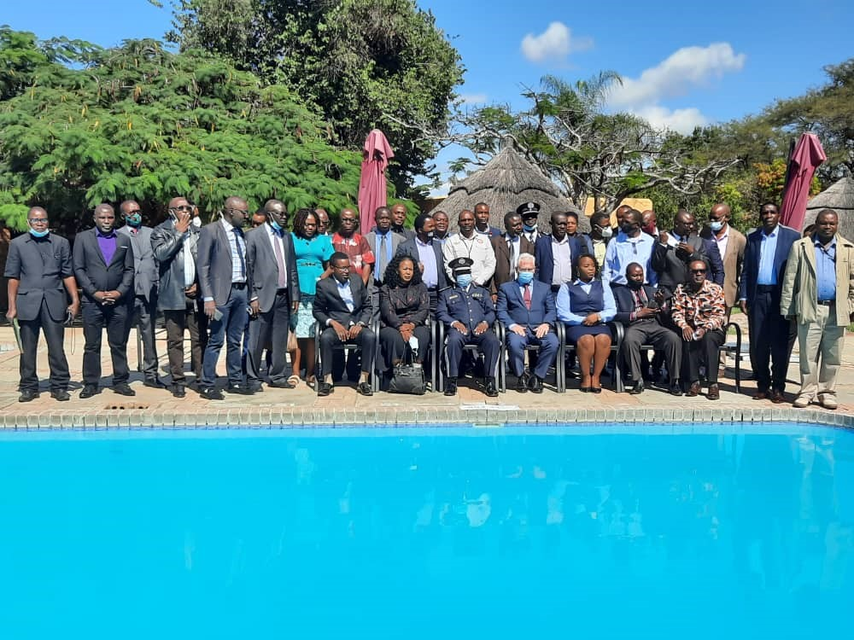

Picture 6: Participants at the one-day consultative meeting themed 'the role of political parties in conflict mitigation' pose for a photo with the Mr. Lionel Lauren-UNDP Resident Representative

1. The meeting clearly underscored the need for sustained multi-stakeholder dialogue to address, among others, political parties’ concerns on the implementation of the Public Order Act and the phenomenon of vigilantism which if left unattended could undermine peaceful elections; political parties also indicated the need for more dialogue among themselves on how they can commit to peaceful elections. The meeting also explored opportunities for their institutional strengthening to effectively engage with the electoral process. Political parties expressed their support for the CVMS concept, and it was agreed that it must be piloted in some districts ahead of the 2021 general election, meaning it will complement the existing manual system of ZPS notification about political parties’ events. The DSZ-recruited consultant presented a prototype application to the meeting and it was agreed this is work in progress and going forward (and on regular basis) the ZPS, ECZ and the political parties will meet to discuss progress on the system development and roll out.

1. The DSZ engaged various partners to prepare for the early implementation of the EWERS ahead of the 12 August 2021 polls. Following extensive discussions between UNDP and national stakeholders, an agreement was reached that, for the time being, the HRC would be the sole responsible party for the EWERS in 2021. It was agreed that the HRC would lead on the implementation of the system after the ECZ expressed concern that due to time and legal constraints it would not be able to co-implement the system with the HRC. The ECZ however expressed the interested to pilot the system in by-elections after the August 2021 polls. The project worked with the HRC to identify the capacity needs of the HRC including staffing, space, and logistics to implement the system at all levels, i.e., national, provincial and district levels.
2. The UNDP-JTF engaged HRC to discuss and identify implementation synergies and modalities for the revised architecture of EWERS system under the leadership of HRC. The system had to take into account the new architecture that made the HRC the responsible party and ensure that the mechanism met the minimum specifications related to an EWERS system at all levels including (i) identifying the HRC’s needs; (ii) preparing in coordination with HRC, a detailed work plan covering different aspects of the activities for the period May-June; (iii) developing a provisional budget; (iv) identifying key partners to ensure monitoring; (v) identifying key partners for the response component. This culminated in UNDP signing LOAs with the HRC, conducting a micro assessment of the HRC to enable UNDP to transfer project funds to the former to implement EWS and other related activities.
3. In the same period, the HRC operationalized the system following the establishment of the EWS Situation Room, recruitment of staff to operate the Situation Room, and training of trainers of stakeholders and partners across the provinces. The Trainer of Trainers training targeted HRC Provincial Investigations Officers (10), HRC Provincial Registry Clerks (10), Situation Room team (9) and the Lusaka-based HRC Management Staff (15). In total, 45 people were trained (30 males and 15 females). The system became operational in June and was officially launched on 1 July 2021.

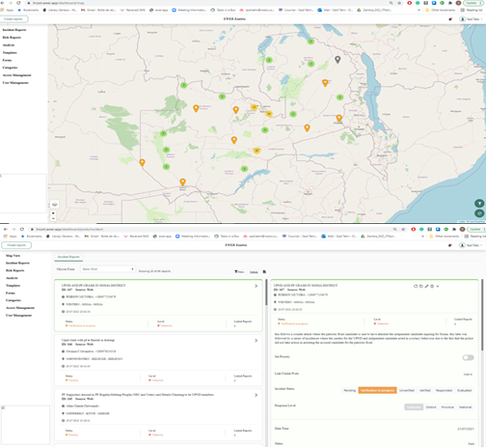

Picture 7: A screen shot of the EWERS Dashboard and Incident Reports showing reported incidents of electoral violence across the country

## Project Management

1. A special technical committee meeting was called and held on 26 May 2021 to discuss and validate the new EWERS to Electoral Violence in Zambia. The meeting provided an opportunity for the HRC as the lead agency to outline their plans for rolling out the EWERS under the revised implementation arrangements. The meeting also provided an opportunity for technical committee members to seek clarification from HRC on their plans for rolling out the EWERS. The meeting in principle affirmed HRC as the lead agency but called on them to ensure that the roll out plan is realistic and considers the realities of time and capacity constraints.
2. UNDP also held a series of meetings with donors to discuss revisions to the workplan and budget design to priorities activities that are linked to elections and deferring others to a later date, or completely dropping them due to changes in implementation arrangements or lack of time to implement them. A revised workplan and budget responding to these realities was due to be submitted for consideration to the next Steering Committee meeting.
3. UNDP also organized a two-day capacity building training for the key personnel of all the 18 grant recipients. Each CSO was represented by the head of the organization, Programme officer and an accountant. The objective of the training was to clarify the roles and responsibilities of the grant recipients on management and administration of the award. The 54 participants were guided through the financial accounting procedures and programmatic reporting of the grants. They also had presentations from Zambia National Public Health Institute on COVID and Elections, MISA Zambia on CSOs and the media, ZPS on the Public Order Act and the CSOs, among other presentations.
4. In the period under review, UNDP signed two LOAs with Panos and HRC to implement the i-Verify Zambia mechanism and EWERS, respectively. The two LoAs formalized the relationship between UNDP and the two responsible parties to implement the activities as outlined in the annual workplan and budget. The agreements also stipulate the conditions for transfer and accountability of funds to the two institutions.
5. UNDP transferred funds amounting to ZMW 7,201,652.00 (USD 320,215.74) to the ZPS for the implementation of selected activities as agreed in the LOA. Further as at the end of the reporting period, funds relating to HRC were being processed.

### Staff Recruitment

1. In the period under review, Mr. Takawira Musavengana joined the DSZ project team as Project Manager and Senior Elections Advisor, taking over from Mr. Joram Rukambe who resigned from this position to pursue other career interests. As Senior Advisor, Mr. Musavengana will provide overall technical leadership to deliver UNDP’s contribution to this highly complex and sensitive project. He will provide high-level technical advice and support to the ECZ and coordinate the implementation of the project in close collaboration with UNDP Assistant Resident Representative – Governance, and a range of cooperating partners and stakeholders that work on electoral assistance to contribute to credible and peaceful elections, counter hate speech and promote non-discrimination.
2. Mr. Musavengana joins UNDP Zambia from UNDP Tanzania, where he served as Senior Parliamentary Advisor. Among other things, he chaired the UN Tanzania’s Development Assistance Plan Outcome Group on Governance, Human Rights and Gender Equality and coordinated the development of UN Tanzania’s COVID-19 Socio-Economic Recovery Framework. He has over eighteen (18) years of experience in national, international, and non-governmental settings on elections and political participation, parliamentary development, security sector governance, human rights, and civil society development. Takawira holds a Master of Management in Public and Development Management from the University of the Witwatersrand, South Africa, a Bachelor of Science in Sociology from the University of Zimbabwe, a Post-Graduate Certificate in Parliamentary Management from McGill University and a Certificate in Security Sector Reform and Peace Building from the Austrian Centre for Peace and Conflict Resolution.

### Project equipment and Assets

1. During this period the Project did not procure any new equipment and assets, these remained the same as those procured in 2020 namely a Toyota Landcruiser station wagon vehicle for operation a printer, 7 laptops and accessories (docking stations, external drives, DVD drives) for the use of the project staff. See a complete list of equipment and assets in the Annexes. The vehicle is kept at the UNDP UN House Office and the laptops were distributed amongst project staff on the project during the period. It should also be noted that the payment for the vehicle was posted in 2021 even though the procurement commitment for the vehicle was raised in 2020.

### Knowledge Management

1. In the period under review, the project made various contributions to the existing body of knowledge on democracy and governance issues in the country. Four (4) consultancies were completed in the second quarter and five (5) important knowledge products were produced, namely.
2. Strategies and Activities to increase Women and Youth in Elections
3. Domestic Elections Monitoring and Observation Operationalization Strategy and Plan
4. Report on Compendium of Status of Electoral Observation Missions Recommendations
5. Final Report on Mapping of Disinformation and Hate Speech in Zambia
6. Report on the Review of Strategies and Procedures for Meaningful Participation of People with Disabilities in Elections in Zambia
7. These knowledge products are designed to support project implementation and serve as reference material for governance and elections programming and policy reforms. The reports have been circulated to stakeholders particularly civil society working with the project for their use. Subject to further editorial work, these products will be published under the project.

### Communication and Visibility Plan (CVP)

1. UNDP continued in the reporting period to implement the project communication and visibility plan. In May 2021, UNDP organized the media event at which the 18 CSOs awarded grants were officially announced and publicly received the dummy cheques. The event was officiated by the H.E Nick Whooley, British High Commissioner, Dr. Coumba Mar Cadio, UN Resident Coordinator; Mr. Yengwe Kakusa, Director of Governance, Ministry of Justice and Mr. Kryticious Patrick Nshindano, Chief Electoral Officer, ECZ (as seen on picture on front cover). The event received coverage in both print and electronic media[4]. It was further tweeted and shared on various partners and UNDP accounts.
2. In the same period organized the official virtual launch of the EWERS to electoral violence at which the support and contributions of the various cooperating partners were acknowledged and highlighted. The launch was streamed live on Facebook[5] and shared on UNDP Zambia and Human Rights Commission[6] official twitter account. UNDP also held an orientation for the representative of the 18 grants recipient organizations on project visibility and communication policies and procedures. The participants were made aware of the need to adhere to the existing communication and visibility policy.
3. In the same vein, UNDP worked with Blackdot (producer for 3rd party voter education media content on behalf of ECZ) to ensure that the materials they produced adhered to the CVP. To this effect all materials produced by Blackdot have a prominent message acknowledging the support of the cooperating partners.
4. Further, the CSO grant recipients continued to implement various initiatives sponsored by the project and as guided by the CVP they collectively produced more than 20, 000 information education and communication materials (radio spots, radio programmes, brochures, posters, flyers etc.) all that acknowledged the financial support of the project donors. The CSOs made sure to acknowledge the support of the donors during trainings and community engagements.
5. The project website ([https://zambia.dsz.ec-undp-electoralassistance.org](https://eur03.safelinks.protection.outlook.com/?url=https%3A%2F%2Fzambia.dsz.ec-undp-electoralassistance.org%2F%3Flang%3Den&data=04%7C01%7Cscott.tembo%40undp.org%7C8fcaecf45c5a47b89b5708d900bdf0a6%7Cb3e5db5e2944483799f57488ace54319%7C0%7C0%7C637541638041512073%7CUnknown%7CTWFpbGZsb3d8eyJWIjoiMC4wLjAwMDAiLCJQIjoiV2luMzIiLCJBTiI6Ik1haWwiLCJXVCI6Mn0%3D%7C1000&sdata=%2Fzp8FthdBwVZZCgF6YF8cExvUI9S2CcpOwbGlPAdrEg%3D&reserved=0)) continues to be operational and provides key information about the project and acknowledges the donors contribution.

Picture 8: Trainee Voter Education Facilitators pose during training in front of a banner acknowledging cooperating partners support to Caritas Mansa, one of the 18 Grant recipients.

|  |
| --- |
| Project Risks and Issues |

1. In the period under review the UNDP continued to monitor the risk profile of the project, engaging with various actors in the implementation environment to manage and mitigate the potential threats to the project success. The specific risks and actions that affected the project in the second quarter are outlined below:

## Updated project risks and actions

**Risk 1: Threats of political and electoral violence in Zambia**

1. There were widely reported reports of sporadic electoral violence during the period under review, leading the ECZ to suspend elections campaigns in selected districts[7]. UNDP[8] and the wider UN system[9] in Zambia continues to engage authorities publicly and in private on the need to maintain a peaceful environment that fosters free participation of the citizens. The operationalization of the EWERS by the HRC with the technical support of UNDP presents opportunities to identify threats of violence and respond to them before they escalate and become disruptive.

**Risk 14: Adverse impact of the COVID-19 pandemic on the electoral process in Zambia**

1. The resurgence of COVID-19 pandemic with the arrival of the third wave caused disruptions to the operations of the project and implementation of the planned activities. Particularly, the ECZ announced the suspension of political rallies and political events which impacted the planned implementation of the campaign venue management system (CVMS). In response, UNDP has proceeded to develop the prototype and will work with the partners to pilot the system post the 12 August general elections.
2. The suspension of gatherings by health authorities also impacted the planned voter education activities by the CSOs. Most CSOs had planned to undertake voter education using the traditional ways of roadshows and community theatre that draw huge crowds. However, with the suspension of gatherings most had to realign their plans and budgets to novel strategies of engaging the communities.

## Updated project issues and actions

|  |
| --- |
| 1. The EWER architecture was revised to make HRC the sole lead and responsible party. This was after ECZ expressed concern that due to time constraints they would not be able to co-lead but would be willing to participate after the general elections. 2. The implementation of the CVMS could not proceed as planned due to the suspension of the rallies by authorities. However, the development of the system proceeds with a view to piloting is when the situation allows after the 12 August general elections as a permanent feature of the country’s electoral politics well into the future. 3. The 2021 project budget was realigned to consider the realities in the implementation environment and defining priorities for the rest of the implementation period.  Challenges and Lessons Learned |

1. The major challenge during the period under review was the arrival of the third wave of the COVID-19 pandemic which saw an increase in number of infections and deaths. This led to UN management to close the offices and put staff on full telecommuting in line with the organization’s policy. This had limited physical interactions with partners and removed all the advantages of face-to-face interactions among staff and partners.
2. The face-to-face trainings planned towards the end of the quarter could not take place as planned and were converted to virtual trainings. However, while UNDP could facilitate and provide IT support to staff and partners sometimes the participants may not fully participate or engage due to poor connectivity in their distant locality. To ensure that these challenges do not adversely affect project delivery, UNDP holds regular consultations and guidance sessions with grantees and partners through combination of telephone, email, and virtual meetings.

|  |  |
| --- | --- |
| |  | | --- | | Conclusions and Way Forward |  1. UNDP made significant progress towards attainment of the project objectives in the second quarter. The award of the 18 grants recipients extended the reach of the project from Lusaka to the fridges of the country for the benefit of the people in hard-to-reach areas. Voter education was carried out by CSOs in far flung places such as Sioma-Western Province, Nchelenge-Luapula and among inmates in at least 39 correctional centers. These strides are a major step towards the project objective of a more inclusive and participatory electoral process. This is consistent with the leaving no one and no place behind principle underpinning the global Sustainable Development Goals. 2. The operationalization of the EWERS presents an opportunity to the stakeholders to use the power of technology to identify and inform identify incidences of potential violence and provide timely and well measured response to make the electoral environment peaceful and more participatory. As the project enters the elections phase of implementation, UNDP seeks to build on these strides to support Zambia to hold a peaceful, transparent, and credible election.  Financial Report |

1. The DSZ project is financially supported by 7 donors namely EU, FCDO, USAID, France, Ireland, Sweden, and UNDP. The project has a multi-year budget of USD 12,159,352 for the period of 2020 -2022. So far, the project has received USD 4,044,016 in funding contributions from its donors with the amount of GPB 500,000 (USD 691,341.78) being received from the most partner to the basket fund - FCDO - in the month of April 2021. It should be noted that the multi-year budget still has a funding gap of USD 1,267,663.
2. The project budget for the year 2021 as proposed to the Project Steering Committee meeting of 2 February 2021 was USD 8,329,867.57. However, this budget was still under review as of 30 June 2021 and was due for consideration at the next of the Steering Committee meeting, to provide a way forward in any revisions to be made to the proposed budget. While awaiting the Steering Committee’s decision on the way forward, the budget utilized the USD 8.3 million figure for reporting purposes. Project expenditure as of 30 June 2021 was at USD 2,473,412.55, which represents 30% of the USD 8.3 million proposed budget. This also represents 20% of the USD 12.1 million multi-year budget.
3. Out of the USD 4,044,016 that has been received as contributions towards the project so far, USD 2,908,934.50 was available for utilization in 2021. The amount of USD 2.9 million comes about because of USD 2,017,593.72 having been carried over from 2020 into 2021 and the amount of USD 891,341.78 having been received during 2021from FCDO and UNDP. Therefore, with the increase in expenditure that took place in June, project funds have reduced significantly. The project has reached out to its donors for the disbursement of contributions that are due in 2021.
4. The following table demonstrates the expenditure within the budget headings/ results It should be noted that the project has not had any budget overrun at the results level. The financial report below provides greater details of the expenditure down to sub activity level and also indicates where sub activities may have over run their budget lines and where the over runs were administratively resolved. Kindly note that the resolving of the sub activity over runs does not constitute a budget revision.



|  |  |  |  |  |  |  |  |  |  |
| --- | --- | --- | --- | --- | --- | --- | --- | --- | --- |
| **ANNEX III: FINANCIAL REPORT ON BUDGET FOR THE ACTION** | | | | | | |  |  |  |
|  | | | | | | |  |  |  |
|  | | | | | | |  |  |  |
| **Financial Progress Report** | | | | | | | | | |
| **Implementation Period ( 1 Jan to 30 Jun 2021)** | | | | | | | | | |
|  | | | | | | |  |  |  |
| **Implementing Partner: United Nations Development Programme (UNDP)** | |  | **ZMB10-00124412** | | | | | | |
| **EXPECTED RESULTS** | **PLANNED ACTIVITIES** |  | **AMOUNT (USD)** | | | | | | |
|  | **Budget** | **Expenditure** | **Commitment** | **Expenditure + Commitments** | **Reallocation of Sub Activity Funds** | **% expenditure per budget heading: (Expenditure + Commitments)/ Budget** | **Comments:** |
| **RESULT AREA 1: ELECTORAL INSTITUTIONS AND PROCESSES STRENGTHENED** | | | | | | | | | |
| **Result 1: Decision-making is more inclusive and participatory, and discrimination is reduced (Gender Marker 3)** | | | | | | |  |  |  |
| **Output 1.1. Support for inclusive participation** | **Activity 1.1.1: Support to women and youth participation in elections** | | | | | | | | |
| i. *Develop and implement strategies/outreach activities to increase women & youth participation in elections: review existing studies, reports and statistical data (virtual meetings/FGDs) on women participation in election; validation and dissemination.* | 1.1.1.1 | 0.00 | 0.00 | 0.00 | 0.00 |  |  |  |
| ii. *Develop knowledge products on women participation in electoral processes in Zambia; validation and dissemination – use of social media/e-learning via Brussels support* | 1.1.1.2 | 24,500.00 | 5,293.00 | 0.00 | 5,293.00 |  |  |  |
| iii. *Outreach activities to increase participation – Civil society-led* | 1.1.1.3 | 550,000.00 | 273,152.44 | 266,214.93 | 539,367.37 |  |  |  |
| iv.Support to Grant Evaluation Committee (CSO and FBO grant evaluation) | 1.1.1.4 | 5,000.00 | 794.17 | 3,518.46 | 4,312.63 |  |  |  |
| v  *Third-Party monitoring of implementation of activities* | 1.1.1.5 | 2,000.00 | 0.00 | 0.00 | 0.00 |  |  |  |
| ***Subtotal*** |  | **581,500.00** | **279,239.61** | **269,733.39** | **548,973.00** |  |  |  |
| **Activity 1.1.2: Participation for Persons with Disabilities (PWDs) in elections increased** | | | | | |  |  |  |
| i. *Review existing procedures/strategies/ publications targeting PWDs for meaningful participation in elections* | 1.1.2.1 | 0.00 | 0.00 | 0.00 | 0.00 |  |  |  |
| ii. *Conduct validation workshop on issues and strategies to improve procedures and remove key barriers to PWDs participation and development of action plan* | 1.1.2.2 | 15,000.00 | 2,010.00 | 3,015.00 | 5,025.00 |  |  |  |
| iii. *Develop draft tools 7 products to improve participation of PWDs in elections.* | 1.1.2.3 | 20,000.00 | 0.00 | 0.00 | 0.00 |  |  |  |
| iv. *Conduct outreach activities to increase participation in elections* | 1.1.2.4 | 135,000.00 | 66,730.63 | 57,356.85 | 124,087.48 |  |  |  |
| ***Subtotal*** |  | **170,000.00** | **68,740.63** | **60,371.85** | **129,112.48** |  |  |  |
| **Activity 1.1.3: Electoral participation of Persons in Lawful Custody [1] (PLC) enhanced** | | | | | |  |  |  |
| i. *Review existing legislations, procedures, issues and propose strategies and recommendations to support participation of individuals in lawful custody (ILC)* | 1.1.3.1 | 0.00 | 0.00 | 0.00 | 0.00 |  |  |  |
| ii. *Stakeholder consultations on ILC participation in elections* | 1.1.3.2 | 0.00 | 0.00 | 0.00 | 0.00 |  |  |  |
| iii. *Bench-making with other countries (South-to-South Cooperation) by multi-disciplinary team* | 1.1.3.3 | 0.00 | 0.00 | 0.00 | 0.00 |  |  |  |
| iv. *Validation workshops on issues and strategies to improve procedures and remove key barriers to voting by PLC and development of action plan.* | 1.1.3.4 | 5,000.00 | 5,081.93 | 0.00 | 5,081.93 |  |  |  |
| v. *Design and production of materials and tools to support voting of PLC* | 1.1.3.5 | 25,000.00 | 3,029.31 | 0.00 | 3,029.31 |  |  |  |
| ***Subtotal*** |  | **30,000.00** | **8,111.24** | **0.00** | **8,111.24** |  |  |  |
| **Output 1.2 Support to improve inclusiveness of the National Assembly** | **Activity 1.2.1: Support Inclusion Measures of the National Assembly** | | | | | |  |  |  |
| ii. UNV support to ongoing work with National Assembly, based on the NA request in 2020. | 1.2.1.1 | 25,000.00 | 0.00 | 0.00 | 0.00 |  |  |  |
| i.Support to ongoing capacity development of female MPs to improve their role as MPs. | 1.2.1.2 | 10,000.00 | 568.92 | 0.00 | 568.92 |  |  |  |
| ii. *Support targeting outreach activities via the Women’s Parliamentary Caucus to promote women’s participation in elections and politics.* | 1.2.1.3 | 40,000.00 | 0.00 | 0.00 | 0.00 |  |  |  |
| ***Subtotal*** |  | **75,000.00** | **568.92** | **0.00** | **568.92** |  |  |  |
| **Activity 1.2.2: Citizen Consultation Platform** | | | | | |  |  |  |
| i. *Develop an online citizen consultation platform to promote sustained interaction between MPs and their electors; support development of online platform for citizens to exchange views on ongoing parliamentary debates and issues.* | 1.2.2.1 | 70,000.00 | 0.00 | 0.00 | 0.00 |  |  |  |
| ii. *Broaden reach of online debates outcomes through public radio and TV programmes.* | 1.2.2.1 | 25,000.00 | 0.00 | 0.00 | 0.00 |  |  |  |
| ***Subtotal*** |  | 95,000.00 | **0.00** | 0.00 | **0.00** |  |  |  |
| **Output 1.3 Support the inclusion of civil society and civic engagement** | **Activity 1.3.1: Strengthened domestic election observation frameworks** | | | | | |  |  |  |
| i. *Support the operationalization of the Domestic Election Monitoring and Observation Group (DEMOG) Charter for local CSOs; validation and dissemination* | 1.3.1.1 | 40,000.00 | 34,500.00 | 0.00 | 34,500.00 |  |  |  |
| ii. *Develop/harmonize monitoring tools/reporting templates and guidelines for domestic observation & operationalize governance arrangements in the Charter* | 1.3.1.2 | 15,000.00 | 0.00 | 0.00 | 0.00 |  |  |  |
| iii. *Facilitate lessons sharing/best practices among CSOs on domestic observation* | 1.3.1.3 | 10,000.00 | 0.00 | 0.00 | 0.00 |  |  |  |
| iv. *Train DEMOG Charter members on domestic observation* | 1.3.1.4 | 15,000.00 | 0.00 | 0.00 | 0.00 |  |  |  |
| v. *Disseminate information on DEMOG to stakeholders via social media and other channels* | 1.3.1.5 | 20,000.00 | 0.00 | 0.00 | 0.00 |  |  |  |
| ***Subtotal*** |  | **100,000.00** | **34,500.00** | **0.00** | **34,500.00** |  |  |  |
| **Activity 1.3.2: Support to traditional leaders and FBOs** | | | | | |  |  |  |
| i. *Identify, via the House of Chiefs, a team of traditional leaders to champion peace messaging and voter education; provide training and support dialogue.* | 1.3.2.1 | 0.00 | 0.00 | 0.00 | 0.00 |  |  |  |
| ii. *Peace messaging and voter and civic education messages developed and disseminated on community radio; special emphasis on rural and hard to reach communities.* | 1.3.2.2 | 60,000.00 | 0.00 | 2,772.17 | 2,772.17 |  |  |  |
| iii. *Identify FBOs to undertake outreach activities to increase participation* | 1.3.2.3 | 125,000.00 | 45,164.71 | 67,427.58 | 112,592.29 |  |  |  |
| v  *Monitoring of implementation of activities* | 1.3.2.4 | 60,000.00 | 0.00 | 0.00 | 0.00 |  |  |  |
| ***Subtotal*** |  | **245,000.00** | **45,164.71** | **70,199.75** | **115,364.46** |  |  |  |
| **Subtotal for Result 1** |  | **1,296,500.00** | **436,325.11** | **400,304.99** | **836,630.10** |  | **65%** |  |
| **Result 2: Institutions are strengthened to be responsive and accountable, providing access and services (Gender Marker: 1)** | | | | | | |  |  |  |
| **Output 2.1 Enhancing Electoral Support Institutions Activity** | **Activity 2.1.1: Parliamentary staff and committees are strengthened** | | | | | |  |  |  |
| i. *Identify training needs of Parliamentary committee and staff in electoral reform* | 2.1.1.1 | 30,000.00 | 309.60 | 0.00 | 309.60 | -4,893.48 |  |  |
| ii. *Provide training to Parliamentary staff in areas such as research, legal drafting and legislative review processes particularly related to electoral reforms; also training in E-Parliament* | 2.1.1.2 | 20,000.00 | 0.00 | 0.00 | 0.00 |  |  |  |
| ***Subtotal*** |  | **50,000.00** | **309.60** | **0.00** | **309.60** |  |  |  |
| **Output 2.2 Support to Electoral Dispute Resolution (EDR)** | **Activity 2.2.1: Strengthen Judiciary Electoral Dispute Resolution (EDR) processes** | | | | | |  |  | Act 2.2.1i The cost of the consultant recruitment was much higher after review of best suited financial and programmatic proposals. |
| i.      *Assess EDR-related training needs and gaps in the Judiciary* | 2.2.1.1 | 10,000.00 | 5,958.00 | 23,832.00 | 29,790.00 | 19,790.00 |  |
| ii.     *Undertake review and develop knowledge products from previous electoral petitions & judgements* | 2.2.1.2 | 80,000.00 | 0.00 | 0.00 | 0.00 |  |  |
| iii.     *Share experiences and best practices on EDR via South-South cooperation: convene a regional colloquium* | 2.2.1.3 | 30,000.00 | 1,044.18 | 14,059.30 | 15,103.48 | -14,896.52 |  |
| iv.     *Provide training to various Judiciary officials on EDR* | 2.2.1.4 | 160,000.00 | 0.00 | 0.00 | 0.00 |  |  |
| ***Subtotal*** |  | **280,000.00** | **7,002.18** | **37,891.30** | **44,893.48** |  |  |
| **Subtotal for Result 2** |  | **330,000.00** | **7,311.78** | **37,891.30** | **45,203.08** |  | **14%** |
| **Result 3: Institutions are more transparent and provide access to information Gender Marker: 1** | | | | | | |  |  |  |
| **Output 3.1 Strategic communications support to ECZ** | **Activity 3.1.1: Support ECZ strategic communications** | | | | | |  |  |  |
| i. *Review current ECZ’s communications strategy to identify gaps, issues and remedial measures responsive to current environment and cognizant of the prevailing risks (pre & post elections)* | 3.1.1.1 | 15,000.00 | 8,557.19 | 3,812.43 | 12,369.62 |  |  |  |
| ii. *Develop crisis communication strategy (consultancy); validation and rollout* | 3.1.1.2 | 10,000.00 | 0.00 | 0.00 | 0.00 |  |  |  |
| iii. *Capacity development ECZ staff in communications and stakeholder engagements, including at district level.* | 3.1.1.3 | 15,000.00 | 0.00 | 0.00 | 0.00 |  |  |  |
| iv. *Facilitate public discussion forums on targeted issues: voter registration, voting of persons in lawful custody) (pre & post)* | 3.1.1.4 | 20,000.00 | 0.00 | 0.00 | 0.00 |  |  |  |
| v. *Develop and implement a media training manual; validation and piloting* | 3.1.1.5 | 15,000.00 | 15,000.00 | 0.00 | 15,000.00 |  |  |  |
| vi. *Produce a media elections handbook and rollout training* | 3.1.1.6 | 10,000.00 | 0.00 | 0.00 | 0.00 |  |  |  |
| vii. *Discussions with media institutions (training) in context of new legislation* | 3.1.1.7 | 4,000.00 | 0.00 | 0.00 | 0.00 |  |  |  |
| viii. *Conduct TOTs of media practitioners (cascade to provincial level)* | 3.1.1.8 | 10,000.00 | 10,000.00 | 0.00 | 10,000.00 |  |  |  |
| ix. *Roll out training of media practitioners at national and provincial level* | 3.1.1.9 | 15,000.00 | 15,000.00 | 0.00 | 15,000.00 |  |  |  |
| x. *Reconstitute the Media Corps and review its TORs* | 3.1.1.10 | 5,000.00 | 5,000.00 | 0.00 | 5,000.00 |  |  |  |
| xi. *Update and upgrade the ECZ Website* | 3.1.1.11 | 15,000.00 | 8,978.67 | 0.00 | 8,978.67 |  |  |  |
| xii. *Support printing of the Electoral Code of Conduct by ECZ.* | 3.1.1.12 | 20,000.00 | 14,996.63 | 0.00 | 14,996.63 |  |  |  |
| xiii. *Develop & disseminate ECZ core messages, timelines, channels of communication and target* | 3.1.1.13 | 80,000.00 | 21,206.86 | 0.00 | 21,206.86 |  |  |  |
| xiv. *Support equipment procurement to enhance ECZ communications capabilities: set up a national call centre to support public interaction with the ECZ via online and digital means/tools.* | 3.1.1.14 | 120,000.00 | 0.00 | 101,839.00 | 101,839.00 |  |  |  |
| ***Subtotal*** |  | **354,000.00** | **98,739.35** | **105,651.43** | **204,390.78** |  |  |  |
| **Output 3.2 Support to the National Assembly communication strategies** | **Activity 3.2.1: Enhance the communication practices of the National Assembly (NA)** | | | | | |  |  |  |
| i. *Support the National Assembly to enhance public access to Parliamentary information* | 3.2.1.1 | 80,000.00 | 0.00 | 0.00 | 0.00 |  |  |  |
| ii. *Support dialogue forums between the NA and the media* | 3.2.1.2 | 20,000.00 | 0.00 | 0.00 | 0.00 |  |  |  |
| iii. *Support implementation of the NA Communication Strategy* | 3.2.1.3 | 165,000.00 | 0.00 | 0.00 | 0.00 |  |  |  |
| ***Subtotal*** |  | **265,000.00** | **0.00** | **0.00** | **0.00** |  |  |  |
| **Output 3.3 Support to the Media** | **Activity 3.3.1: Strengthening independent and responsible media reporting** | | | | | |  |  |  |
| i. *Review electoral laws and media codes of conduct* | 3.3.1.1 | 15,000.00 | 0.00 | 0.00 | 0.00 |  |  |  |
| ii. *Facilitate dialogue and training on the Safety of Journalists;* | 3.3.1.2 | 0.00 | 0.00 | 0.00 | 0.00 |  |  |  |
| iii. *Provide technical and advisory services to improve the legal framework for public and private media; validate, print out content and roll it out.* | 3.3.1.3 | 50,000.00 | 0.00 | 0.00 | 0.00 |  |  |  |
| iv. *Support inclusive dialogue throughout the electoral cycle (candidates debates, public discussions)* | 3.3.1.4 | 325,000.00 | 0.00 | 0.00 | 0.00 |  |  |  |
| v. *Support dialogue forums between the Independent Broadcasting Authority and media on responsible reporting and media freedom related to elections* | 3.3.1.5 | 10,000.00 | 0.00 | 0.00 | 0.00 |  |  |  |
| vi. *Participate in media code of conduct revisions or development/reform processes* | 3.3.1.6 | 20,000.00 | 0.00 | 0.00 | 0.00 |  |  |  |
| vii. *Development of an IT platform to identify and tackle disinformation and hate speech during elections* | 3.3.1.7 | 100,000.00 | 16,000.00 | 0.00 | 16,000.00 |  |  |  |
| viii. *Carry out post-election analysis of media and elections* | 3.3.1.8 | 0.00 | 0.00 | 0.00 | 0.00 |  |  |  |
| v  Monitoring of implementation | 3.3.1.9 | 500.00 | 0.00 | 0.00 | 0.00 |  |  |  |
| ***Subtotal*** |  | **520,500.00** | **16,000.00** | **0.00** | **16,000.00** |  |  |  |
| ***Subtotal for Result 3*** |  | **1,139,500.00** | **114,739.35** | **105,651.43** | **220,390.78** |  | **19%** |  |
| **Result 4: Technical and organisational capacities of national electoral stakeholders strengthened Gender Marker: 1** | | | | | | |  |  | Act 4.1.1ii the Logistics consultant was recruited, and the costs encumbered in 2020 but the payments to the consultant paid in 2021 |
| **Output 4.1. Technical support and capacity strengthening for the ECZ** | **Activity 4.1.1: Provision of technical support to ECZ** | | | | | |  |  |
| i. *Assess/review ECZ key functions including systems, capacity, procedures and recommend actions to improve these areas* | 4.1.1.1 | 25,000.00 | 9,675.98 | 0.00 | 9,675.98 |  |  |
| ii. *Render logistics and operations support to the ECZ’s voter registration and voting processes* | 4.1.1.2 | 60,000.00 | 70,959.65 | 0.00 | 70,959.65 | 10,959.65 |  |
| iii. *Undertake ECZ capacity building/institutional strengthening: Prioritize key actions for implementation (e.g., re-engineering of systems, training, strengthening of systems, Bridge training; conflict management, (voter/education registration and logistical management)* | 4.1.1.3 | 150,000.00 | 88,332.21 | 5,199.38 | 93,531.59 | -10,959.65 |  |
| iv. Support ECZ SOPs on election observer accreditation and receipt of observer reports | 4.1.1.4 | 20,000.00 | 0.00 | 0.00 | 0.00 |  |  | Act 4.1.1ii The ECZ Communications Expert was recruited, and the costs encumbered in 2020 but the payments to the consultant paid in 2021. |
| ***Subtotal*** |  | **255,000.00** | **168,967.84** | **5,199.38** | **174,167.22** |  |  |
| **Activity 4.1.2: Provision of voter education** | | | | | |  |  |
| i. *Recruit Outreach/Communications Expert to support VE strategy development, validation and roll out including printing and dissemination.* | 4.1.2.1 | 10,000.00 | 48,984.39 | 0.00 | 48,984.39 | 38,984.39 |  |
| ii. *Review and develop voter education content, including core messages, review approaches for various audiences (women, youth, PWDs) and platforms educational materials and means incl. the use of innovative technologies/social media with focus on targeted audiences* | 4.1.2.2 | 5,000.00 | 8,847.96 | 0.00 | 8,847.96 | 3,847.96 |  | Act 4.1.2ii The cost of field research for the Women and Youth inclusion consultant carried out research in 2 provinces was more than the original budget |
| iii. *Undertake voter and civic education activities (recruitment, training, and deployment): ·       National voter education trainers (40) ·       District (232) ·       District Voter education committees (116) ·       Voter education facilitators (2 per ward)* | 4.1.2.3 | 40,000.00 | 34,130.04 | 0.00 | 34,130.04 |  |  |
| iv. *Disseminate the 2018/2019 post 2016 voter turn-out research (printing)* | 4.1.2.4 | 5,000.00 | 0.00 | 0.00 | 0.00 |  |  |
| v. *Development of MOUs with CSOs (women, youth, PWDs) to increase coordination and standardization of messages (link to activity 1.1.2)* | 4.1.2.5 | 80,000.00 | 2,244.67 | 0.00 | 2,244.67 |  |  |
| vi. Recruit 3rd Party to undertake activities below[2]: |  |  |  |  |  |  |  |  |
| 1. *Targeted voter and civic education for women and youth (especially first-time voters) through existing voter education school club structures* | 4.1.2.6 | 15,000.00 | 0.00 | 0.00 | 0.00 |  |  |  |
| 2. *Design various electronic voter education awareness and publicity products (electoral reforms and regulations)* | 4.1.2.7 | 110,000.00 | 0.00 | 0.00 | 0.00 |  |  |  |
| 3. *Broadcast PSA on voter registration/education in 7 languages (community radios, television, social media)* | 4.1.2.8 | 83,000.00 | 0.00 | 0.00 | 0.00 |  |  |  |
| 4. *Print flyers, brochures, pamphlets and press-kits, posters (10 provinces)* | 4.1.2.9 | 50,000.00 | 0.00 | 0.00 | 0.00 | -42,832.35 |  |  |
| 5. *Publication of the voter education/registration deployment schedules in print media* | 4.1.2.10 | 80,000.00 | 0.00 | 0.00 | 0.00 |  |  |  |
| 6. *Publication of information products/inserts in newspapers (voter registration/education);* | 4.1.2.11 | 55,000.00 | 0.00 | 0.00 | 0.00 |  |  |  |
| 7.  *Development of voter registration/education manuals, voter education guidelines, translation in braille and other languages.* | 4.1.2.12 | 25,000.00 | 0.00 | 0.00 | 0.00 |  |  |  |
| 8. *Support the Establishment of Voter Education School Clubs* | 4.1.2.13 | 0.00 | 0.00 | 0.00 | 0.00 |  |  |  |
| 9.  *Support Peer (Voter) Educators in tertiary institutions.* | 4.1.2.14 | 40,000.00 | 0.00 | 0.00 | 0.00 |  |  |  |
| 10. *Conduct voter turnout survey* | 4.1.2.15 | 0.00 | 0.00 | 0.00 | 0.00 |  |  |  |
| vii. *Revitalize the voter education resource centre/knowledge management centre* | 4.1.2.16 | 50,000.00 | 13,468.01 | 0.00 | 13,468.01 |  |  |  |
| viii. *Undertake study to identity and fill civic education gaps current school curriculum* | 4.1.2.17 | 50,000.00 | 0.00 | 0.00 | 0.00 |  |  |  |
| ix.  *Integration of voter education content in the national school curriculum* | 4.1.2.18 | 0.00 | 0.00 | 0.00 | 0.00 |  |  |  |
| x. *Update and alignment voter education handbook content with MOGE school curriculum* | 4.1.2.19 | 25,000.00 | 0.00 | 0.00 | 0.00 |  |  |  |
| xi. *Formative research on voter education and registration activities and guidelines (end of 2021 and early 2022); validate and disseminate reports* | 4.1.2.20 | 25,000.00 | 0.00 | 0.00 | 0.00 |  |  |  |
| v  Monitoring activities: Field visits to perform oversights of grants and cash transfers made to CSOs and local partners and oversee project implementation activities such as media campaigns, focus group discussions, etc. | 4.1.2.21 | 4,000.00 | 0.00 | 0.00 | 0.00 |  |  |  |
| ***Subtotal*** |  | **752,000.00** | **107,675.07** | **0.00** | **107,675.07** |  |  |  |
| **Subtotal for Result 4** |  | **1,007,000.00** | **276,642.91** | **5,199.38** | **281,842.29** |  | **28%** |  |
| **Result 5: Credible and legitimate institutions work with integrity Gender Marker: 2** | | | | | | |  |  |  |
| **Output 5.1 Support to the reform process** | **Activity 5.1.1: Legal and regulatory assessment, consolidation and analysis of observer recommendations** | | | | | |  |  |  |
| i. *Review gaps between Constitution/legislative framework and procedural/regulatory framework* | 5.1.1.1 | 0.00 | 0.00 | 0.00 | 0.00 |  |  |  |
| ii. *Review, analyse, and consolidate observer recommendations* | 5.1.1.2 | 30,000.00 | 0.00 | 0.00 | 0.00 |  |  |  |
| iii. *Undertake knowledge sharing events/dialogue forums to inform key legal drafters, policy makers and other stakeholders on gaps requiring redress* | 5.1.1.3 | 35,000.00 | 0.00 | 0.00 | 0.00 |  |  |  |
| ***Subtotal*** |  | **65,000.00** | **0.00** | **0.00** | **0.00** |  |  |  |
| **Activity 5.1.2: Support to the legal drafting process** | | | | | |  |  |  |
| i. *Review voter registration regulations* | 5.1.2.1 | 0.00 | 0.00 | 0.00 | 0.00 |  |  |  |
| ii. *Support drafting sessions for electoral legislations/ Voter Education regulations* | 5.1.2.2 | 0.00 | 0.00 | 0.00 | 0.00 |  |  |  |
| iii. *Support drafting sessions for new/revised legislation, policies, processes* | 5.1.2.3 | 20,000.00 | 0.00 | 0.00 | 0.00 |  |  |  |
| iv. *Conduct research on Diaspora voting in Zambia (post-election); South-South lessons learning and best practices facilitate South to South Cooperation on Diaspora voting (If feasible undertaken with voting for individuals in lawful custody)* | 5.1.2.4 | 40,000.00 | 0.00 | 0.00 | 0.00 |  |  |  |
| v. *Support consultative forums on legal reforms bearing on the electoral environment* | 5.1.2.5 | 20,000.00 | 0.00 | 0.00 | 0.00 |  |  |  |
| vi. *Design, print & disseminate legal reform products/findings* | 5.1.2.6 | 35,000.00 | 0.00 | 0.00 | 0.00 |  |  |  |
| vii. *Undertake analytical and research activities on legal reforms with potential impacted the electoral environment (post-election)* | 5.1.2.7 | 0.00 | 0.00 | 0.00 | 0.00 |  |  |  |
| viii. *Sensitization of stakeholders and citizens on legal framework supporting elections and democracy in the country* | 5.1.2.8 | 0.00 | 0.00 | 0.00 | 0.00 |  |  |  |
| ***Subtotal*** |  | **115,000.00** | **0.00** | **0.00** | **0.00** |  |  |  |
| **Activity 5.1.3: Technical assistance in the engendering of relevant legislation** | | | | | |  |  |  |
| i.  *Support fulfilment of international and regional commitments that encourage effective women participation in elections* | 5.1.3.1 | 20,000.00 | 3,587.52 | 0.00 | 3,587.52 |  |  |  |
| ii. *Provide training and capacity building to relevant women’s organisations on women’s political participation.* | 5.1.3.2 | 30,000.00 | 0.00 | 0.00 | 0.00 |  |  |  |
| iii. *Undertake analytical/research work on the viability of temporal special measures to increase women’s’ participation; support dialogue on the viability of temporary special measures to increase women’s participation in all facets of Government.* | 5.1.3.3 | 10,000.00 | 0.00 | 0.00 | 0.00 |  |  |  |
| ***Subtotal*** |  | **60,000.00** | **3,587.52** | **0.00** | **3,587.52** |  |  |  |
| **Output 5.2 Support to the integrity of biometric identification** | **Activity 5.2.1: Supporting biometric identification (i.e., pilot roll-out of digital identity cards in targeted locations)** | | | | | |  |  |  |
| i.  *Procure critical software (public key infrastructure software to encode chips) for biometric registration kits will facilitate the development of the system* | 5.2.1.1 | 385,000.00 | 0.00 | 0.00 | 0.00 |  |  |  |
| ii. *Assess the viability of the digital card as means of improving the voter’s card.* | 5.2.1.2 | 15,000.00 | 0.00 | 0.00 | 0.00 |  |  |  |
| iii. *Develop and share products based on the analysis of the roll-out of the digital identity cards* | 5.2.1.3 | 20,000.00 | 0.00 | 0.00 | 0.00 |  |  |  |
| ***Subtotal*** |  | **420,000.00** | **0.00** | **0.00** | **0.00** |  |  |  |
| **Subtotal for Result 5** |  | **660,000.00** | **3,587.52** | **0.00** | **3,587.52** |  | **1%** |  |
| **Results Area 2: Programming for Peace** | | | | | | |  |  |  |
| **Result 6: Conflict mitigation mechanisms to support the peaceful conduct of elections are enhanced Gender Marker: 1** | | | | | | |  |  |  |
| **Output 6.1 Promote electoral security Output** | **Activity 6.1.1: Police training on rights and electoral security** | | | | | |  |  |  |
| i. *Review ZPS training and resource materials (i.e., ToT handbook and pocketbook) on electoral security* | 6.1.1.1 | 5,000.00 | -148.35 | 0.00 | -148.35 |  |  |  |
| ii. *Provide electoral security training to ZPS.* | 6.1.1.2 | 15,000.00 | 10,292.32 | 3,076.20 | 13,368.52 |  |  |  |
| iii. *Support printing of the 2016 General Election Report* | 6.1.1.3 | 0.00 | 0.00 | 0.00 | 0.00 |  |  |  |
| iv. *Conduct ToT for ZPS on electoral security (i.e., 65 police officers)* | 6.1.1.4 | 25,000.00 | 0.00 | 0.00 | 0.00 |  |  |  |
| v. *Prepare plans/schedules and roll out of ZPS electoral security training (i.e., 19,400 police officers).* | 6.1.1.5 | 280,000.00 | 287,867.87 | 0.00 | 287,867.87 | 7,867.87 |  |  |
| vi.  *Provide pre-service on electoral security in the two national academies* | 6.1.1.6 | 44,000.00 | 0.00 | 0.00 | 0.00 | -7,867.87 |  |  |
| v  *Third-Party monitoring of implementation of activities* | 6.1.1.7 | 2,000.00 | 0.00 | 0.00 | 0.00 |  |  |  |
| ***Subtotal*** |  | **371,000.00** | **298,011.84** | **3,076.20** | **301,088.04** |  |  |  |
| **Activity 6.1.2: Support the development and establishment of a transparent Campaign Venue Management System (CVMS)** | | | | | |  |  |  |
| i.  *Support dialogue platforms between political parties and stakeholders on campaign venue management* | 6.1.2.1 | 15,000.00 | 2,213.86 | 0.00 | 2,213.86 |  |  |  |
| ii. *Develop a transparent campaign management venue system: validate the system* | 6.1.2.2 | 60,000.00 | 0.00 | 4,846.60 | 4,846.60 |  |  |  |
| iii.  *Provide training on the use of CVMS by stakeholders.* | 6.1.2.3 | 35,000.00 | 0.00 | 0.00 | 0.00 |  |  |  |
| v  *Monitor roll-out and application of the system by stakeholders* | 6.1.2.4 | 3,000.00 | 0.00 | 0.00 | 0.00 |  |  |  |
| ***Subtotal*** |  | **113,000.00** | **2,213.86** | **4,846.60** | **7,060.46** |  |  |  |
| **Activity 6.1.3: Community policing initiative** | | | | | |  |  |  |
| i. *Identify targeted locations through the electoral violence risk assessment (developed under 6.2.1) to pilot a community policing* | 6.1.3.1 | 0.00 | 0.00 | 0.00 | 0.00 |  |  |  |
| ii. *Provide training to crime prevention officers in targeted areas (identified as high risk)* | 6.1.3.2 | 5,000.00 | 2,542.38 | 0.00 | 2,542.38 |  |  |  |
| iii. *Provide training to community members in crime prevention (electoral), methods and strategies in areas with potential electoral violence* | 6.1.3.3 | 25,000.00 | 25,000.00 | 0.00 | 25,000.00 |  |  |  |
| iv. *Conduct stakeholders dialogue forums between churches, political parties and CSOs on community policing; produce anti-violence publicity materials.* | 6.1.3.4 | 55,000.00 | 55,000.00 | 0.00 | 55,000.00 |  |  |  |
| v. *Support public awareness activities community policing targeted at citizens and police in specific location* | 6.1.3.5 | 135,000.00 | 12,655.16 | 0.00 | 12,655.16 |  |  |  |
| v  *Monitoring of implementation of activities* | 6.1.3.6 | 5,000.00 | 0.00 | 0.00 | 0.00 |  |  |  |
| ***Subtotal*** |  | **225,000.00** | **95,197.54** | **0.00** | **95,197.54** |  |  |  |
| **Activity 6.1.4: Joint training of police and media** | | | | | |  |  |  |
| i. *Undertake joint training sessions for ZPS and media organizations on public order management and respect for freedom of expression: possible roll out to province level* | 6.1.4.1 | 95,000.00 | 0.00 | 1,749.66 | 1,749.66 |  |  |  |
| ii. *Publish brief information products on Police and Media in Elections* | 6.1.4.2 | 15,000.00 | 0.00 | 0.00 | 0.00 |  |  |  |
| iii.  *Undertake publicity and information sharing on police and media training activities to create public awareness* | 6.1.4.3 | 25,000.00 | 0.00 | 0.00 | 0.00 |  |  |  |
| ***Subtotal*** |  | **135,000.00** | **0.00** | **1,749.66** | **1,749.66** |  |  |  |
| **6.2 Support to political violence early warning system** | **Activity 6.2.1: Early Warning System Design implemented by JTF** | | | | | |  |  |  |
| i. *Conduct Analysis/Mapping of existing Early Warning related initiatives and capacities* | 6.2.1.1 | 15,000.00 | 12,233.88 | 0.00 | 12,233.88 |  |  |  |
| ii. *Conduct electoral violence risk assessment* | 6.2.1.2 | 0.00 | 0.00 | 0.00 | 0.00 |  |  |  |
| iii. *Draft and finalize the EWS design and architecture report* | 6.2.1.3 | 0.00 | 0.00 | 0.00 | 0.00 |  |  |  |
| iv. *Develop Standard Operating Procedures (SOP) and related content* | 6.2.1.4 | 0.00 | 0.00 | 0.00 | 0.00 |  |  |  |
| v. *Develop Work plan and Procurement Plan; monitoring and updating* | 6.2.1.5 | 7,500.00 | 7,212.15 | 0.00 | 7,212.15 |  |  |  |
| ***Subtotal*** |  | **22,500.00** | **19,446.03** | **0.00** | **19,446.03** |  |  |  |
| **Activity 6.2.2. Training of actors and officials on EWS** | | | | | |  |  |  |
| i. *Support EWS content development and rollout (by JTF)* | 6.2.2.1 | 0.00 | 0.00 | 0.00 | 0.00 |  |  |  |
| ii. *Develop and rollout ToT scheme and implementation plan (by JTF)* | 6.2.2.2 | 10,000.00 | 1,536.68 | 0.00 | 1,536.68 |  |  |  |
| iii. *Deliver EWS training at national, provincial and district levels (salaries of trainers & DSA for participants)* | 6.2.2.3 | 300,000.00 | 0.00 | 0.00 | 0.00 |  |  |  |
| ***Subtotal*** |  | **310,000.00** | **1,536.68** | **0.00** | **1,536.68** |  |  |  |
| **Activity 6.2.3 Customization and maintenance of the IT system** | | | | | |  |  |  |
| i. *Develop and deploy EWS monitoring software: drafting of technical specifications and TORs (by JTF)* | 6.2.3.1 | 0.00 | 0.00 | 0.00 | 0.00 |  |  |  |
| ii. *Continued support to the EWS maintenance.* | 6.2.3.2 | 10,000.00 | 0.00 | 0.00 | 0.00 |  |  |  |
| ***Subtotal*** |  | **10,000.00** | **0.00** | **0.00** | **0.00** |  |  |  |
| **Activity 6.2.4 Short Term specialized consultancies (international) (Early Warning Expert, Procurement and reporting expert)** | | | | | |  |  |  |
| i. *Recruitment of Early Warning Expert and other experts as maybe needed by the project.* | 6.2.4.1 | 100,000.00 | 46,153.37 | 21,122.50 | 67,275.87 |  |  |  |
| ***Subtotal*** |  | **100,000.00** | **46,153.37** | **21,122.50** | **67,275.87** |  |  |  |
| **Activity 6.2.5 National communication/outreach campaign** | | | | | |  |  |  |
| i. *Production and roll out of Early Warning campaign materials; leaflets and other types of materials including online content.* | 6.2.5.1 | 75,000.00 | 0.00 | 15,696.00 | 15,696.00 |  |  |  |
| ***Subtotal*** |  | **75,000.00** | **0.00** | **15,696.00** | **15,696.00** |  |  |  |
| **Activity 6.2.6 Capacitating the EWS mechanism** | | | | | |  |  |  |
| ii. *Central team staffing (6 persons) for early warning system* | 6.2.6.1 | 54,000.00 | 0.00 | 0.00 | 0.00 |  |  |  |
| ii. EWS partners (2*118 districts) | 6.2.6.2 | 210,000.00 | 0.00 | 0.00 | 0.00 |  |  |  |
| ***Subtotal*** |  | **264,000.00** | **0.00** | **0.00** | **0.00** |  |  |  |
| **Activity 6.2.7 Procurement Situation Room** | | | | | |  |  |  |
| iii.  *Situation Room/National CMC/Analyses team (communication, transport, office space, translation, etc.); Province Hubs/CMC’s and district level CMCs* | 6.2.7.1 | 350,000.00 | 1,701.11 | 46,618.21 | 48,319.32 |  |  |  |
| ***Subtotal*** |  | **350,000.00** | **1,701.11** | **46,618.21** | **48,319.32** |  |  |  |
| **Activity 6.2.8 Developing and deploying preventive actions** | | | | | |  |  |  |
| i.  *Strengthening mediative capacity* | 6.2.8.1 | 75,000.00 | 0.00 | 0.00 | 0.00 |  |  |  |
| ii. *Training of staff involved in provincial hubs* | 6.2.8.2 | 20,000.00 | 0.00 | 0.00 | 0.00 |  |  |  |
| iii. *Capacity support to the HRC hotline (information material, training, staff)* | 6.2.8.3 | 40,000.00 | 0.00 | 0.00 | 0.00 |  |  |  |
| ***Subtotal*** |  | **135,000.00** | **0.00** | **0.00** | **0.00** |  |  |  |
| **Output 6.3 Strengthening of conflict management mechanisms** | **Activity 6.3.1 Support to Conflict Management Committees (Support the capacity development of Conflict Management Committees in targeted high-risk locations):** | | | | | |  |  |  |
| i. *Peace awareness training (youths, political parties, chiefs)* | 6.3.1.1 | 60,000.00 | -99.45 | 0.00 | -99.45 |  |  |  |
| ii. *Review of Conflict Management Guidelines Manuals; validate* | 6.3.1.2 | 0.00 | 0.00 | 0.00 | 0.00 |  |  |  |
| iii. *Printing of guidelines and manuals for CMCs* | 6.3.1.3 | 30,000.00 | 0.00 | 0.00 | 0.00 |  |  |  |
| iv. *Training of the National Conflict Management Committee and targeted areas (including hotspots)* | 6.3.1.4 | 40,000.00 | 0.00 | 0.00 | 0.00 |  |  |  |
| v. *Development of peace awareness materials (ICT materials) for conflict prevention* | 6.3.1.5 | 65,000.00 | 0.00 | 0.00 | 0.00 |  |  |  |
| ·       *Monitoring of implementation of activities* | 6.3.1.6 | 2,000.00 | 0.00 | 0.00 | 0.00 |  |  |  |
| ***Subtotal*** |  | **197,000.00** | **-99.45** | **0.00** | **-99.45** |  |  |  |
| **Subtotal for Result 6** |  | **2,307,500.00** | **464,160.98** | **93,109.17** | **557,270.15** |  | **24%** |  |
| **7. Project Management/Project Office** | **7.1 Project Management Unit Team** | | | | | |  |  |  |
| 7.1.1 Senior Elections Advisor/ Programme Manager FTA P5 (3 years) (100%) | 7.1.1 | 269,504.88 | 163,465.98 | 0.00 | 163,465.98 |  |  |  |
| 7.1.2 Programme Specialist FTA P3 (3 years) (100%) | 7.1.2 | 167,950.40 | 0.00 | 0.00 | 0.00 | -104,809.00 |  |  |
| 7.1.3 Programme Officer (100%) | 7.1.3 | 38,551.20 | 9,231.39 | 0.00 | 9,231.39 |  |  |  |
| 7.1.4 Finance/Administration Specialist (100%) | 7.1.4 | 38,551.20 | 9,231.39 | 0.00 | 9,231.39 |  |  |  |
| 7.1.5 Project Officer (Monitoring, Evaluation and Knowledge Management) (100%) | 7.1.5 | 24,999.25 | 20,118.27 | 0.00 | 20,118.27 |  |  |  |
| 7.1.6 Project Associate (100%) | 7.1.6 | 13,800.00 | 12,509.00 | 0.00 | 12,509.00 |  |  |  |
| 7.1.7 Driver (100%) | 7.1.7 | 23,640.00 | 5,669.99 | 0.00 | 5,669.99 |  |  |  |
| 7.1.8 Cost of UNDP staff rendering enabling services to the project in areas such as: Human Resources, Procurement, Finances, Administration and Logistics - see Sheet 2 for Breakdown of cost per each staff position & also Sheet 3 for Justification. | 7.1.8 | 211,730.04 | 0.00 | 0.00 | 0.00 |  |  |  |
| 7.1.9 Short term experts and specialised consultancies | 7.1.9 | 45,196.00 | 26,101.50 | 67,500.00 | 93,601.50 | 48,405.50 |  | Act 7.1.9 The cost of hiring of the short-term consultant including the Communications Expert was higher than the budget indicated. |
| 7.1.10 Project Visibility and Communication support (Project visibility activities and communication support, including communication equipment, JTF visibility/website) | 7.1.10 | 50,000.00 | 86.26 | 913.22 | 999.48 |  |  |
| 7.1.11 General Operating Expenses (Office supplies, Rental costs, Material and Equipment for the project team, utility charges, other operating expenses for the project) | 7.1.11 | 88,000.00 | 64,133.70 | 139.07 | 64,272.77 |  |  |
| 7.1.12 Purchase of a liaison vehicle for the project team, including costs related to the fuel, maintenance, insurance, etc. | 7.1.12 | 0.00 | 56,403.50 | 0.00 | 56,403.50 | 56,403.50 |  | Act 7.1.12 This is a posting of the payment for the purchase of the project vehicle that was encumbered in 2020. Hence the zero budget for 2021. |
| 7.1.13 Audit and mid-term and final evaluation Costs | 7.1.13 | 62,500.00 | 0.00 | 0.00 | 0.00 |  |  |
| 7.1.14 Capacity assessment of identified local partners and responsible parties to carry out targeted activities | 7.1.14 | 10,000.00 | 0.00 | 3,250.00 | 3,250.00 |  |  |
| **7. Project Management/Project Office Subtotal** |  | **1,044,422.97** | **366,950.98** | **71,802.29** | **438,753.27** |  |  |  |
| **Subtotal Outputs - Direct Eligible Costs** | |  | **7,784,922.97** | **1,669,718.63** | **713,958.56** | **2,383,677.19** |  |  |  |
| **Indirect Eligible Costs 7%** | | **9.1** | **544,944.60** | **89,735.36** | **0.00** | **89,735.36** |  | **33%** |  |
| **Total Eligible Costs** | |  | **8,329,867.57** | **1,759,453.99** | **713,958.56** | **2,473,412.55** | **0.00** |  |  |

Listing of Equipment and Assets Procured by the Project as of 30th June 2021





1. It is extracted word for word from the final release of the 7th National Development Plan (7NDP).
2. http://onlinesystems.zicta.zm:8585/statsfinal/Core%20ICT%20Indicators%20-%20HH.html
3. [Mwiza Zulu - VOTERS CHECKLIST #GoOutToVote SACCORD (facebook.com)](https://web.facebook.com/MwizaZulu1/videos/2986798788262630/?__cft__%5b0%5d=AZWsoGyoM--0HEudrOZmt4Fai6dlPj2gmtNXA2-c8Hxfmn825C91MDUdfQ5MnvkwoVSXFwCm1hmcds25igSW53iJWhCXwmmrI2PVTk4QvhYPmSQMCRD1__eKEkvFByhIlXogatKtOWAljezLoFu-Cl-CopL1dkKWVGb4k7JXEJgghQ&__tn__=%2CO%2CP-R)
4. https://www.lusakatimes.com/2021/05/21/csos-receive-grants-for-voter-education/
5. https://web.facebook.com/watch/live/?v=342790483881146&ref=watch_permalink
6. https://twitter.com/hrc_zambia/status/1410554285939646465
7. <https://www.elections.org.zm/2021/06/11/the-electoral-commission-of-zambia-has-noted-with-serious-concern-the-escalating-campaign-violence-ahead-of-the-12th-august-general-election-especially-in-lusaka-and-some-selected-parts-of-the-country/>

   <https://www.elections.org.zm/2021/06/28/speech-by-the-chief-electoral-officer-mr-kryticous-patrick-nshindano-during-a-virtual-briefing-held-on-tuesday-28th-june-2021-held-at-elections-house/>
8. <https://twitter.com/UNDPZambia/status/1394950446243057665>
9. <https://zambia.un.org/en/129986-press-statement-special-representative-united-nations-secretary-general-african-union-and?fbclid=IwAR0XgI3f08xhTR-Smd0sY0PN3_XlXplSobf5QPE8FBCWwv-5d6DkZCyWdjg>